Приложение А (обязательное)

Диаграммы модели разрабатываемого приложения в формате IDEF0

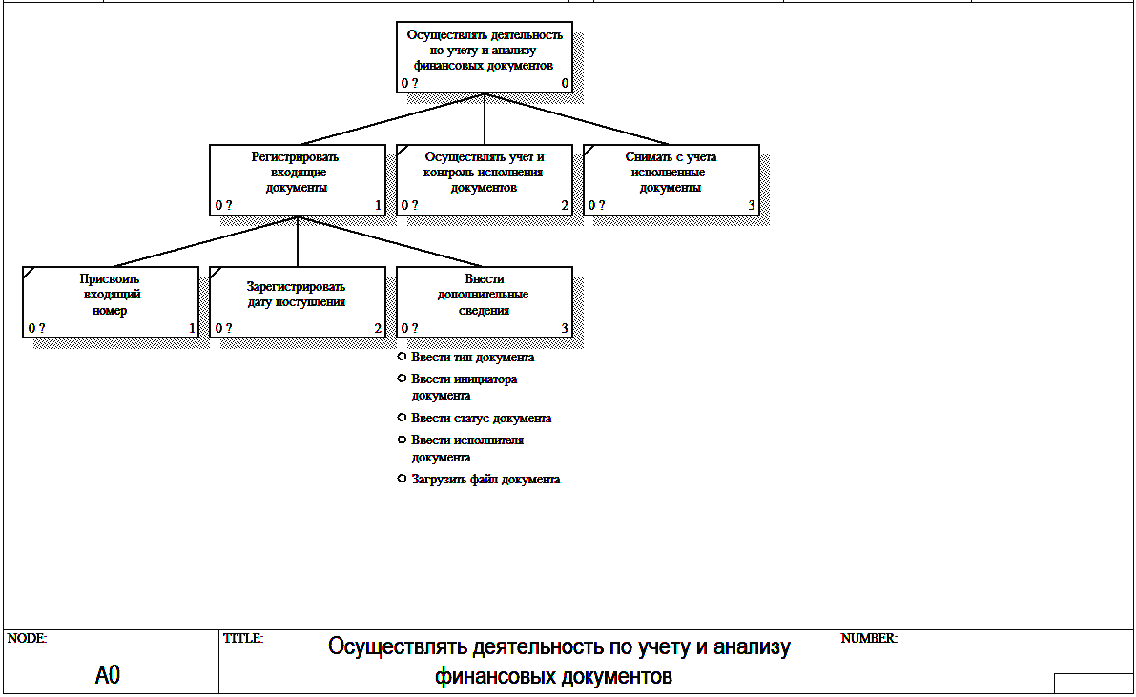
Рисунок А.1 – Контекстная диаграмма
Приложение А (продолжение)

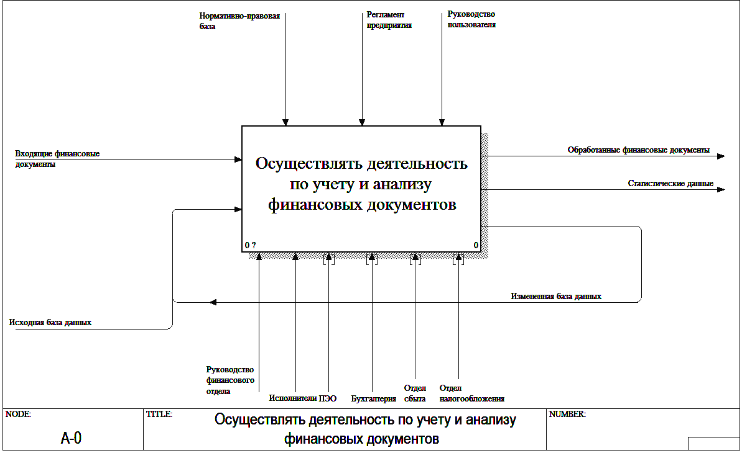

Рисунок А.2 – Диаграмма декомпозиции, уровень А-0

Приложение А (продолжение)

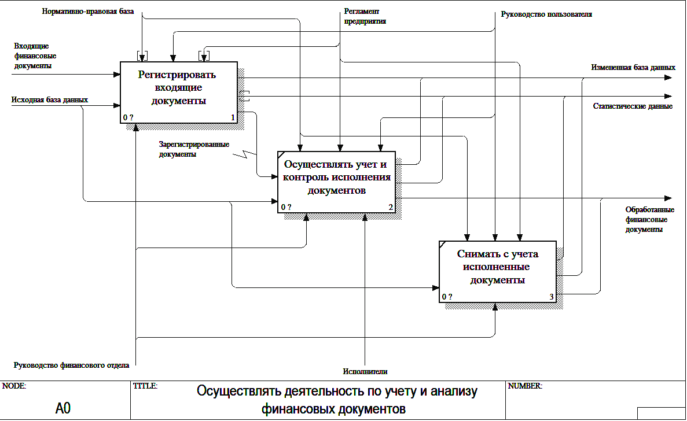

Рисунок А.3 – Диаграмма декомпозиции, уровень А0
Приложение А (продолжение)

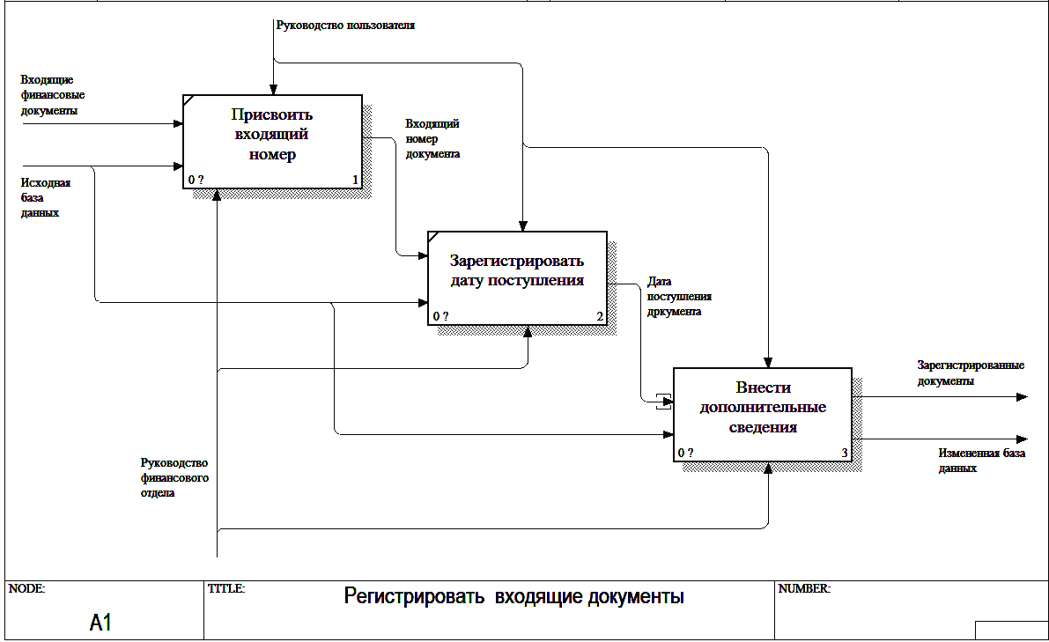

Рисунок А.4 – Диаграмма декомпозиции, уровень А1
Приложение А (продолжение)

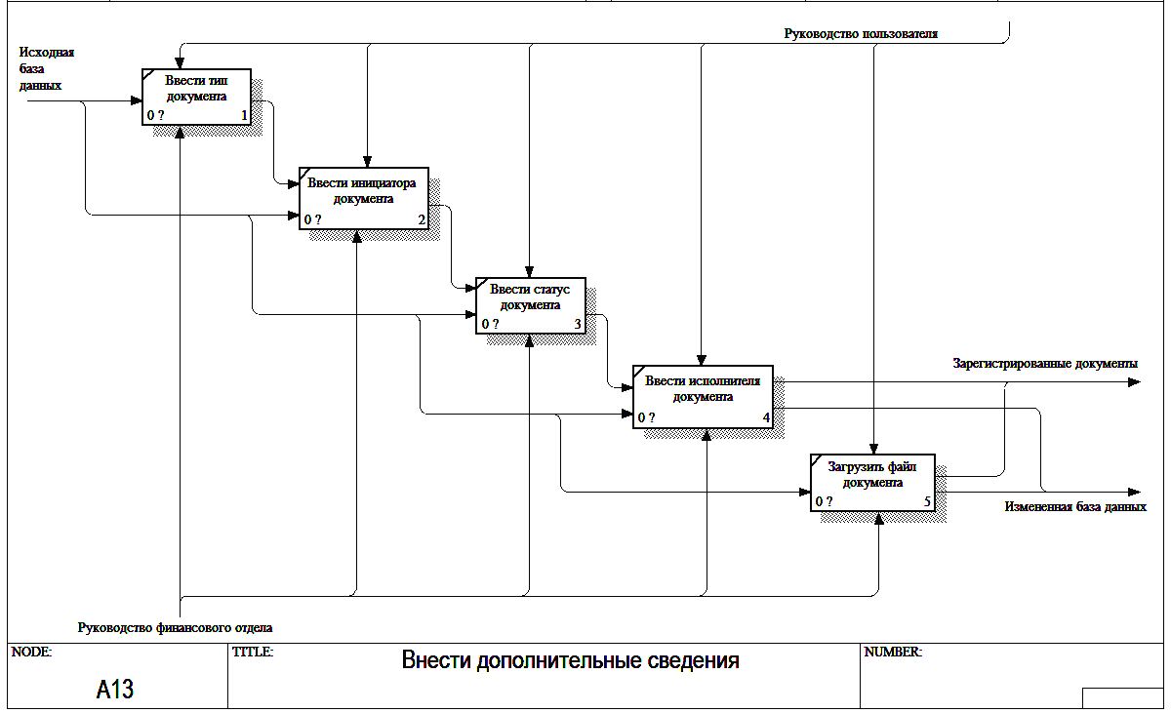

Рисунок А.5 – Диаграмма декомпозиции, уровень А13

Приложение Б (обязательное)

UML-диаграммы разрабатываемой системы

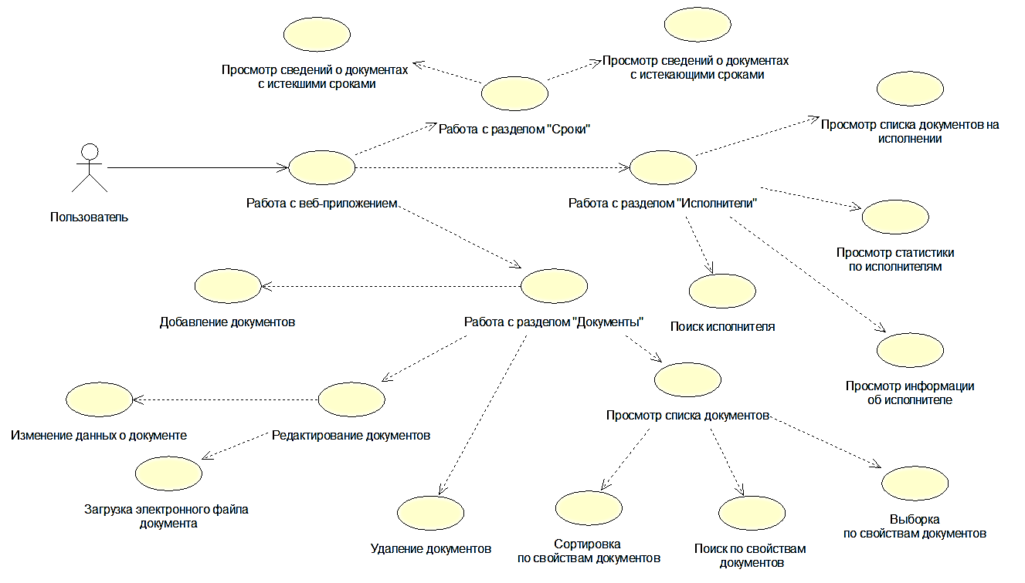

Рисунок Б.1 – Диаграмма вариантов использования
Приложение Б (продолжение)
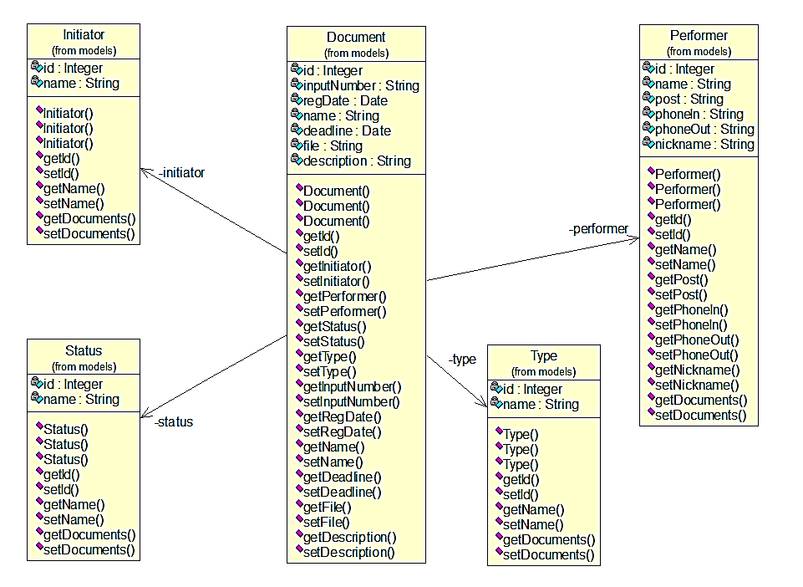
Рисунок Б.2 – Диаграмма классов (модели)
Приложение Б (продолжение)

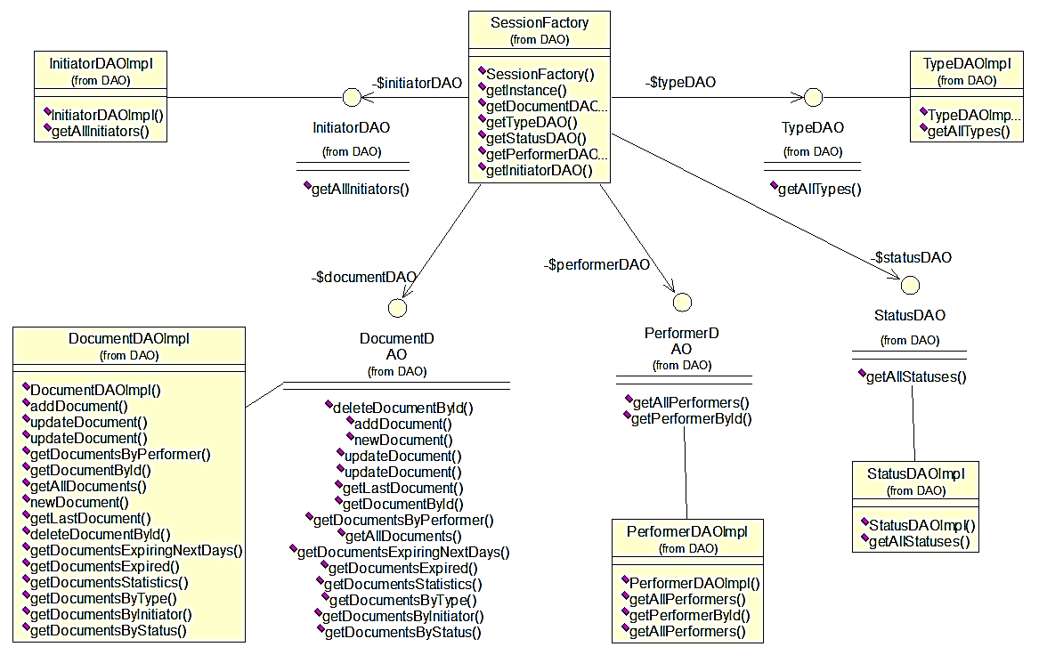

Рисунок Б.3 – Диаграмма классов (DAO)
Приложение Б (продолжение)
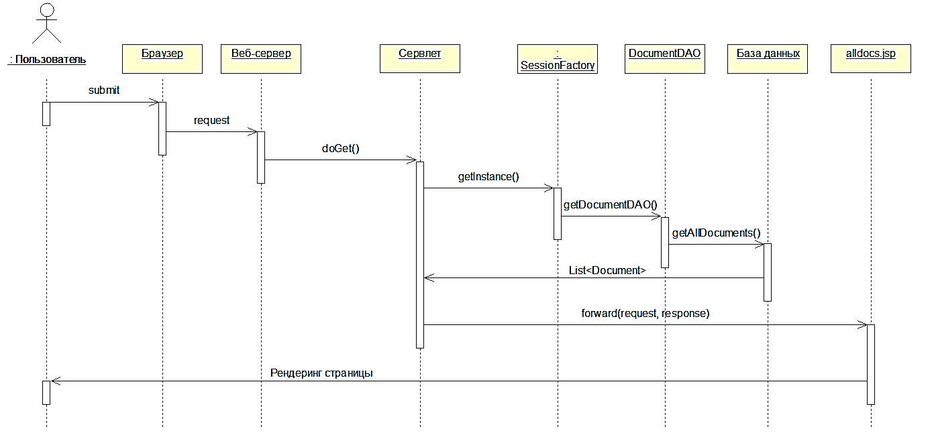
Рисунок Б.4 – Диаграмма последовательности

Приложение В (обязательное)
Листинг кода скрипта генерации базы данных

CREATE DATABASE IF NOT EXISTS `fin_dept_docs`;
USE `fin_dept_docs`;

CREATE USER 'dbadmin'@'localhost' IDENTIFIED BY 'dbadmin';
GRANT ALL PRIVILEGES ON * . * TO 'dbadmin'@'localhost';

--
-- Table structure for table `document`
--

DROP TABLE IF EXISTS `document`;
CREATE TABLE `document` (
`id` int(10) unsigned NOT NULL AUTO_INCREMENT,
`input_number` varchar(10) NOT NULL,
`reg_date` date NOT NULL,
`name` varchar(200) NOT NULL,
`type_id` int(10) unsigned NOT NULL,
`performer_id` int(10) unsigned NOT NULL,
`initiator_id` int(10) unsigned NOT NULL,
`deadline` date NOT NULL,
`status_id` int(10) unsigned NOT NULL,
`file` varchar(200) DEFAULT NULL,
`description` varchar(500) DEFAULT NULL,
PRIMARY KEY (`id`),
UNIQUE KEY `doc_id_UNIQUE` (`id`),
UNIQUE KEY `file_UNIQUE` (`file`),
KEY `FK_initiator` (`initiator_id`),
KEY `FK_status` (`status_id`),
KEY `FK_type` (`type_id`),
KEY `FK_performer` (`performer_id`)
) ENGINE=InnoDB AUTO_INCREMENT=11 DEFAULT CHARSET=utf8;

--
-- data for table `document`
--

LOCK TABLES `document` WRITE;
INSERT INTO `document` VALUES (1,'01/16','2015-11-15','План реализации продукции на 1 кв. 2016 г.',5,2,3,'2015-12-15',5,'План реализации продукции на 1 кв. 2016 г..pdf',''),(2,'02/16','2016-02-16','План реализации \n\nпродукции на 2 кв. 2016 г.',5,3,3,'2016-03-16',5,NULL,NULL),(3,'03/16','2016-05-17','План реализации продукции на 3 кв. 2016 г.',5,4,3,'2016-06-17',3,NULL,NULL),(5,'01/17','2016-11-26','План реализации продукции на 1 кв. 2017 г.',5,9,3,'2016-12-26',1,NULL,NULL),(6,'02/17','2017-01-28','План реализации продукции на 2 кв. 2017 \n\nг.',5,7,3,'2017-02-28',2,NULL,NULL),(22,'5/17','2017-01-01','План амортизационных отчислений на 2017 год',6,17,2,'2017-12-31',2,'План амортизационных отчислений на 2017 год.pdf',''),(23,'5/16','2016-01-01','План амортизационных отчислений на 2016 год',6,17,2,'2016-12-31',1,NULL,''),(24,'5/15','2015-01-01','План амортизационных отчислений на 2015 год',6,17,2,'2015-12-31',3,NULL,''),(25,'6/16','2016-01-01','Кассовый план на 2 полугодие 2016',4,2,3,'2016-12-31',1,NULL,''),(26,'6/17','2017-01-01','Кассовый план на 1 полугодие 2017',4,10,3,'2017-03-31',2,'Кассовый план на 1 полугодие 2017.pdf',''),(27,'7/17','2017-04-01','Кассовый план на 2 полугодие 2017',4,2,3,'2017-06-30',2,NULL,''),(28,'8/17','2017-02-23','Кредитная заявка Беларусбанк',11,12,1,'2017-03-02',2,NULL,NULL),(29,'9/17','2017-02-25','Кредитная заявка МТБанк',11,11,1,'2017-02-26',2,'Кредитная заявка МТБанк.pdf',''),(30,'10/17','2017-02-16','Кредитная заявка БПС-Сбербанк',11,13,1,'2017-02-23',2,NULL,''),(31,'11/16','2016-12-14','План капитального ремонта здания ул.Филимонова, 53',8,5,3,'2017-02-05',2,NULL,''),(32,'6/16','2016-11-01','План
Приложение В (продолжение)

модернизации VoIP-телефонии офиса',8,10,3,'2017-03-16',2,'План модернизации VoIP-телефонии офиса.pdf',''),(33,'7/16','2016-09-13','Строительство торгового павильона',7,11,3,'2017-06-24',2,NULL,''),(34,'12/17','2017-02-22','Выплаты из прибыли 2016 года',9,7,2,'2017-04-07',2,NULL,''),(36,'7/16','2016-11-01','Разработка Положения о закупках',2,6,1,'2017-04-01',2,NULL,''),(37,'13/16','2016-09-06','Разработка Положения о премировании',2,3,5,'2017-04-13',2,NULL,''),(38,'14/16','2016-09-20','Разработка Учетной политики по налоговому учету на 2017 год',1,14,6,'2016-12-31',2,NULL,''),(39,'7/15','2015-08-11','Разработка Учетной политики по налоговому учету на 2016 год',1,6,6,'2016-01-01',1,NULL,''),(40,'15/17','2017-02-01','Кредитная заявка Беларусбанк',11,4,1,'2017-02-11',2,NULL,''),(41,'15/46','2017-02-20','План распределения балансовой прибыли на 2 кв. 2017 года',9,1,2,'2017-03-15',2,NULL,''),(42,'15/47','2017-02-01','Кредитная заявка Беларусбанк (в евро)',11,4,1,'2017-03-11',2,NULL,NULL),(43,'15/48','2017-02-26','Кредитная заявка Беларусбанк (в долларах США)',11,9,1,'2017-03-17',2,NULL,NULL),(44,'15/79','2017-02-24','Кредитная заявка МТБанк (в евро)',11,4,1,'2017-03-22',2,NULL,NULL),(45,'15/88','2017-02-25','Кредитная заявка БПС-Сбербанк (в евро)',11,9,1,'2017-03-22',2,NULL,NULL),(46,'16/106','2017-02-01','План капитального ремонта складского помещения (филиал 1)',8,1,3,'2017-03-15',2,'План капитального ремонта складского помещения (филиал 1).pdf',NULL),(47,'16/106','2017-02-11','План капитального ремонта складского помещения (филиал 2)',8,17,3,'2017-02-27',2,NULL,NULL),(48,'16/106','2017-02-17','План капитального ремонта складского помещения (филиал 3)',8,14,3,'2017-03-02',2,NULL,NULL),(49,'16/106','2017-02-05','План капитального ремонта складского помещения (филиал 4)',8,16,3,'2017-03-10',2,NULL,NULL),(50,'50/81','2017-02-11','План реализации продукции (позиция 006-01) на 2 кв. 2017 г.',5,2,4,'2017-03-03',2,'План реализации продукции (позиция 006-01) на 2 кв. 2017 г..pdf',NULL),(51,'50/82','2017-02-12','План реализации продукции (позиция 006-02) на 2 кв. 2017 г.',5,3,4,'2017-03-06',2,NULL,NULL),(52,'50/83','2017-02-13','План реализации продукции (позиция 006-03) на 2 кв. 2017 г.',5,5,4,'2017-03-14',2,NULL,NULL),(53,'50/84','2017-02-14','План реализации продукции (позиция 006-04) на 2 кв. 2017 г.',5,6,4,'2017-03-06',2,NULL,NULL),(54,'50/85','2017-02-15','План реализации продукции (позиция 006-05) на 2 кв. 2017 г.',5,18,4,'2017-03-03',2,NULL,NULL),(55,'50/93','2017-02-16','План реализации продукции (позиция 006-06) на 2 кв. 2017 г.',5,16,4,'2017-03-08',2,NULL,NULL),(56,'50/94','2017-02-17','План реализации продукции (позиция 006-07) на 2 кв. 2017 г.',5,12,4,'2017-03-04',2,NULL,NULL),(57,'50/96','2017-02-18','План реализации продукции (позиция 006-08) на 2 кв. 2017 г.',5,2,4,'2017-03-11',2,NULL,NULL),(58,'50/99','2017-02-19','План реализации продукции (позиция 006-09) на 2 кв. 2017 г.',5,3,4,'2017-03-22',2,NULL,NULL),(59,'17/105','2017-02-03','План капитального ремонта заготовительного цеха (филиал 7)',8,1,3,'2017-04-17',2,NULL,''),(60,'17/106','2017-02-05','План капитального ремонта производственного цеха (филиал 2)',8,2,3,'2017-04-15',2,NULL,NULL),(61,'17/13','2017-02-18','План капитального ремонта производственного цеха (филиал 3)',8,13,3,'2017-04-18',2,NULL,NULL),(62,'12/98','2017-02-10','План капитального ремонта производственного цеха (филиал 4)',8,1,3,'2017-04-11',2,NULL,NULL),(63,'15/87','2017-02-10','План капитального ремонта производственного цеха (филиал 5)',8,18,3,'2017-04-10',2,NULL,NULL);
UNLOCK TABLES;

--
-- Table structure for table `initiator`
--

DROP TABLE IF EXISTS `initiator`;
CREATE TABLE `initiator` (
`id` int(11) unsigned NOT NULL AUTO_INCREMENT,
`name` varchar(45) NOT NULL,
PRIMARY KEY (`id`),
UNIQUE KEY `id_UNIQUE` (`id`)
) ENGINE=InnoDB AUTO_INCREMENT=7 DEFAULT CHARSET=utf8;

--
-- data for table `initiator`
--

LOCK TABLES `initiator` WRITE;
INSERT INTO `initiator` VALUES (1,'Финансовый отдел'),(2,'Бухгалтерия'),(3,'Планово-экономический отдел'),(4,'Отдел сбыта'),(5,'Отдел труда и зарплаты'),(6,'Отдел налогообложения');
Приложение В (продолжение)

UNLOCK TABLES;

--
-- Table structure for table `performer`
--

DROP TABLE IF EXISTS `performer`;
CREATE TABLE `performer` (
`id` int(11) unsigned NOT NULL AUTO_INCREMENT,
`name` varchar(45) NOT NULL,
`post` varchar(100) DEFAULT NULL,
`phone_in` varchar(10) DEFAULT NULL,
`phone_out` varchar(20) DEFAULT NULL,
`nickname` varchar(20) DEFAULT NULL,
PRIMARY KEY (`id`),
UNIQUE KEY `id_UNIQUE` (`id`)
) ENGINE=InnoDB AUTO_INCREMENT=19 DEFAULT CHARSET=utf8;

--
-- data for table `performer`
--

LOCK TABLES `performer` WRITE;
INSERT INTO `performer` VALUES (1,'Иванова А.А.','Заместитель начальника отдела','102','(017) 215-17-89',NULL),(2,'Синицын А.Ю.','Экономист 2 категории','103','(017) 215-17-
89',NULL),(3,'Павлова А.Н.','Экономист 1 категории','104','(017) 215-17-96',NULL),(4,'Варламов Н.Е.','Специалист','105','(017) 215-17-98',NULL),(5,'Постоловский
А.Б.','Экономист 2 категории','106','(017) 215-18-15',NULL),(6,'Карасев Е.Ю.','Начальник отдела','101','(017) 215-18-20',NULL),(7,'Филлимонов К.Е.','Финансовый
аналитик','107','(017) 215-18-25',NULL),(8,'Беляева О.И.','Ведущий специалист','108','(017) 215-18-27',NULL),(9,'Никифоров А.Ю.','Экономист 2 категории','109','(017) 215-18-
26',NULL),(10,'Горький С.А.','Экономист 1 категории','110','(017) 215-18-27',NULL),(11,'Пилюлин П.Р.','Финансовый аналитик','111','(017) 215-18-88',NULL),(12,'Шохин
Е.К.','Специалист','112','(017) 215-18-36',NULL),(13,'Туров М.С.','Экономист 1 категории','113','(017) 215-18-64',NULL),(14,'Александрова И.И.','Финансовый
аналитик','114','(017) 215-18-17',NULL),(15,'Болтрукевич В.В.','Ведущий специалист','115','(017) 215-18-74',NULL),(16,'Сошников А.А.','Экономист 2 категории','116','(017)
215-18-66',NULL),(17,'Панкратов П.П.','Ведущий специалист','117','(017) 215-18-78',NULL),(18,'Прохоров Д.Л.','Экономист 1 категории','118','(017) 215-18-33',NULL);
UNLOCK TABLES;

--
-- Table structure for table `status`
--

DROP TABLE IF EXISTS `status`;
CREATE TABLE `status` (
`id` int(10) unsigned NOT NULL AUTO_INCREMENT,
`name` varchar(45) NOT NULL,
PRIMARY KEY (`id`),
UNIQUE KEY `status_id_UNIQUE` (`id`)
) ENGINE=InnoDB AUTO_INCREMENT=6 DEFAULT CHARSET=utf8;

--
-- data for table `status`
--

LOCK TABLES `status` WRITE;
INSERT INTO `status` VALUES (1,'Обработан/выполнен'),(2,'Принят к обработке'),(3,'Обработка отменена'),(4,'Не требует обработки'),(5,'Выведен из документооборота');
Приложение В (продолжение)

UNLOCK TABLES;

--
-- Table structure for table `type`
--

DROP TABLE IF EXISTS `type`;
CREATE TABLE `type` (
`id` int(10) unsigned NOT NULL AUTO_INCREMENT,
`name` varchar(80) NOT NULL,
PRIMARY KEY (`id`),
UNIQUE KEY `type_id_UNIQUE` (`id`),
UNIQUE KEY `type_name_UNIQUE` (`name`)
) ENGINE=InnoDB AUTO_INCREMENT=12 DEFAULT CHARSET=utf8;

--
-- Dumping data for table `type`
--

LOCK TABLES `type` WRITE;
INSERT INTO `type` VALUES (3,'График'),(4,'Кассовый план'),(11,'Кредитная заявка'),(6,'План амортизационных отчислений'),(10,'План по налогу \n\nс оборота'),(9,'План
распределения балансовой прибыли'),(5,'План реализации продукции'),(8,'План финансирования капитального ремонта основных фондов'),(7,'План финансирования капитальных
вложений'),(2,'Положение'),(1,'Проект документа');
UNLOCK TABLES;

-- FK

ALTER TABLE `fin_dept_docs`.`document`
ADD CONSTRAINT `FK_initiator`
FOREIGN KEY (`initiator_id`)
REFERENCES `fin_dept_docs`.`initiator` (`id`)
ON DELETE NO ACTION
ON UPDATE NO ACTION,
ADD CONSTRAINT `FK_perfomer`
FOREIGN KEY (`performer_id`)
REFERENCES `fin_dept_docs`.`performer` (`id`)
ON DELETE NO ACTION
ON UPDATE NO ACTION,
ADD CONSTRAINT `FK_status`
FOREIGN KEY (`status_id`)
REFERENCES `fin_dept_docs`.`status` (`id`)
ON DELETE NO ACTION
ON UPDATE NO ACTION,
ADD CONSTRAINT `FK_type`
FOREIGN KEY (`type_id`)
REFERENCES `fin_dept_docs`.`type` (`id`)
ON DELETE NO ACTION
ON UPDATE NO ACTION;

Приложение Г (обязательное)

Листинг кода разрабатываемого приложения

DocumentDAO.java
package DAO;

import java.sql.SQLException;
import java.util.Collection;
import models.Document;

public interface DocumentDAO {
public void addDocument(Document doc) throws SQLException ;
public void newDocument(String input_number, String reg_date, String name,
String type_id, String initiator_id, String status_id, String deadline,
String performer_id, String description) throws SQLException ;
public void updateDocument(int id, Document doc) throws SQLException;
public void updateDocument(int id, String input_number, String reg_date, String name,
String type_id, String initiator_id, String status_id, String deadline, String performer_id,
String file, String description);
public Document getLastDocument() throws SQLException;
public Document getDocumentById(int id) throws SQLException;
public void deleteDocumentById(int id) throws SQLException;
public Collection getDocumentsByPerformer(int performer_id) throws SQLException;
public Collection getAllDocuments() throws SQLException;
public Collection getDocumentsExpiringNextDays(int days) throws SQLException;
public Collection getDocumentsExpired() throws SQLException;
public Collection getDocumentsStatistics() throws SQLException;
public Collection getDocumentsByType(int id) throws SQLException;
public Collection getDocumentsByInitiator(int id) throws SQLException;
public Collection getDocumentsByStatus(int id) throws SQLException;
}

DocumentDAOImpl.java
package DAO;

import java.sql.DriverManager;
import java.sql.SQLException;
import java.text.DateFormat;
import java.text.ParseException;
import java.text.SimpleDateFormat;
import java.util.ArrayList;
import java.util.Collection;
import java.util.Date;
import java.util.List;
import java.util.Locale;
import java.util.logging.Level;
import java.util.logging.Logger;
import models.Document;
import models.Initiator;
import models.Type;
import models.Performer;
import models.Status;
import org.hibernate.Criteria;
import org.hibernate.HibernateException;
Приложение Г (продолжение)

import org.hibernate.Query;
import org.hibernate.SQLQuery;

import org.hibernate.Session;
import util.HibernateUtil;

public class DocumentDAOImpl implements DocumentDAO {

@Override
public void addDocument(Document doc) throws SQLException {
Session session = null;
try {
session = HibernateUtil.getSessionFactory().getCurrentSession();
session.beginTransaction();
session.save(doc);
session.getTransaction().commit();
} catch (HibernateException e) {
DriverManager.println("Ошибка при вставке");
} finally {
if (session != null && session.isOpen()) {
session.close();
}
}
}

@Override
public void updateDocument(int id, Document doc) throws SQLException {
Session session = null;
try {
session = HibernateUtil.getSessionFactory().getCurrentSession();
session.beginTransaction();

String hql = "update fin_dept_docs.document set"
+ " document.input_number = :input_number, "
+ " document.reg_date = :reg_date, "
+ " document.name = :name, "
+ " document.type_id = :type_id, "
+ " document.initiator_id = :initiator_id, "
+ " document.status_id = :status_id, "
+ " document.deadline = :deadline, "
+ " document.performer_id = :performer_id, "
+ " document.file = :file, "
+ " document.description = :description "
+ "WHERE id = :id";
Query query = (Query) session.createSQLQuery(hql);
query.setParameter("input_number", doc.getInputNumber());
query.setParameter("reg_date", doc.getRegDate());
query.setParameter("name", doc.getName());
query.setParameter("type_id", doc.getType().getId());
query.setParameter("initiator_id", doc.getInitiator().getId());
query.setParameter("status_id", doc.getStatus().getId());
query.setParameter("deadline", doc.getDeadline());
query.setParameter("performer_id", doc.getPerformer().getId());
query.setParameter("file", doc.getFile());
query.setParameter("description", doc.getDescription());
query.setParameter("id", id);
Приложение Г (продолжение)

query.executeUpdate();
session.getTransaction().commit();

} catch (HibernateException e) {
throw e;
} finally {
if (session != null && session.isOpen()) {
session.close();
}
}
}

@Override
public void updateDocument(int id, String input_number, String reg_date, String name,
String type_id, String initiator_id, String status_id, String deadline, String performer_id,
String file, String description) {

Session session = null;
try {
session = HibernateUtil.getSessionFactory().openSession();
session.beginTransaction();

String hql = "update document set"
+ " input_number = :input_number, "
+ " reg_date = :reg_date, "
+ " name = :name, "
+ " type_id = :type_id, "
+ " initiator_id = :initiator_id, "
+ " status_id = :status_id, "
+ " deadline = :deadline, "
+ " performer_id = :performer_id, ";
if (file != "") {
hql += " file = :file, ";
}

hql += " description = :description "
+ "WHERE id = :id";
Query query = (Query) session.createSQLQuery(hql);
query.setParameter("input_number", input_number);
query.setParameter("reg_date", reg_date);
query.setParameter("name", name);
query.setParameter("type_id", type_id);
query.setParameter("initiator_id", initiator_id);
query.setParameter("status_id", status_id);
query.setParameter("deadline", deadline);
query.setParameter("performer_id", performer_id);
if (file != "") {
query.setParameter("file", file);
}
query.setParameter("description", description);
query.setParameter("id", id);
query.executeUpdate();
session.getTransaction().commit();

} catch (HibernateException e) {
throw e;
Приложение Г (продолжение)

} finally {
if (session != null && session.isOpen()) {
session.close();
}
}
}

@Override
public Collection getDocumentsByPerformer(int performer_id) throws SQLException {
Session session = null;
List documents = new ArrayList<>();
try {
session = HibernateUtil.getSessionFactory().openSession();

String sql = "SELECT * FROM document WHERE performer_id = " + performer_id + " ORDER BY deadline ASC";
SQLQuery query = session.createSQLQuery(sql);
query.setResultTransformer(Criteria.ALIAS_TO_ENTITY_MAP);

documents = query.list();

} catch (Exception e) {

} finally {
if (session != null && session.isOpen()) {
session.close();
}
}
return documents;
}

@Override
public Document getDocumentById(int id) throws SQLException {
Session session = null;
Document doc = new Document();
try {
session = HibernateUtil.getSessionFactory().openSession();
doc = (Document) session.load(Document.class, id);

} finally {
if (session != null && session.isOpen()) {
session.close();
}
}
return doc;
}

@Override
public Collection getAllDocuments() throws SQLException {
Session session = null;
List<Document> documents = new ArrayList<>();
try {

session = HibernateUtil.getSessionFactory().openSession();
documents = session.createCriteria(Document.class).list();
} catch (Exception e) {
throw e;
Приложение Г (продолжение)

} finally {
if (session != null && session.isOpen()) {
session.close();
}
}
return documents;
}

@Override
public void newDocument(String input_number, String reg_date, String name,
String type_id, String initiator_id, String status_id, String deadline,
String performer_id, String description) throws SQLException {

Session session = null;
try {
session = HibernateUtil.getSessionFactory().getCurrentSession();
session.beginTransaction();

Document doc = new Document();
DateFormat format = new SimpleDateFormat("yyyy-MM-dd", Locale.ENGLISH);

doc.setInputNumber(input_number);

Date regDate = format.parse(reg_date);
doc.setRegDate(regDate);

doc.setName(name);

Type type = new Type();
type.setId(Integer.parseInt(type_id));
doc.setType(type);

Initiator initiator = new Initiator();
initiator.setId(Integer.parseInt(initiator_id));
doc.setInitiator(initiator);

Status status = new Status();
status.setId(Integer.parseInt(status_id));
doc.setStatus(status);

Date deadlineDate = format.parse(deadline);
doc.setDeadline(deadlineDate);

Performer performer = new Performer();
performer.setId(Integer.parseInt(performer_id));
doc.setPerformer(performer);

doc.setDescription(description);
doc.setFile(null);

session.save(doc);
session.getTransaction().commit();

} catch (HibernateException e) {
throw e;
} catch (ParseException ex) {
Logger.getLogger(DocumentDAOImpl.class.getName()).log(Level.SEVERE, null, ex);
Приложение Г (продолжение)

} finally {
if (session != null && session.isOpen()) {
session.close();
}
}
}

@Override
public Document getLastDocument() throws SQLException {
Session session = null;
Document lastDoc = new Document();
List<Document> documents = new ArrayList<>();
try {

session = HibernateUtil.getSessionFactory().openSession();
documents = session.createCriteria(Document.class).list();
lastDoc = documents.get(documents.size() - 1);
} catch (HibernateException e) {
throw e;
} finally {
if (session != null && session.isOpen()) {
session.close();
}
}
return lastDoc;
}

@Override
public void deleteDocumentById(int id) throws SQLException {
Session session = null;
try {
session = HibernateUtil.getSessionFactory().openSession();
session.beginTransaction();
session.delete(getDocumentById(id));
session.getTransaction().commit();
} finally {
if (session != null && session.isOpen()) {
session.close();
}
}
}

@Override
public Collection getDocumentsExpiringNextDays(int days) throws SQLException {
Session session = null;
List documents = new ArrayList<>();
try {
session = HibernateUtil.getSessionFactory().openSession();

String sql = "SELECT \n"
+ "document.id, \n"
+ "document.input_number, \n"
+ "document.reg_date,\n"
+ "document.`name`,\n"
+ "performer.name AS performerName,\n"
+ "initiator.name AS initiatorName,\n"
+ "deadline,\n"
Приложение Г (продолжение)

+ "status.name AS statusName,\n"
+ "DATEDIFF(deadline,CURDATE()) AS expDays"
+ "\n"
+ "FROM fin_dept_docs.document \n"
+ "\n"
+ "JOIN fin_dept_docs.initiator ON document.initiator_id = initiator.id\n"
+ "JOIN fin_dept_docs.performer ON document.performer_id = performer.id\n"
+ "JOIN fin_dept_docs.status ON document.status_id = status.id\n"
+ "\n"
+ "WHERE deadline >= curdate() AND DATEDIFF(deadline,CURDATE()) <=" + days + "\n"
+ "\n"
+ "ORDER BY deadline ASC";
SQLQuery query = session.createSQLQuery(sql);
query.setResultTransformer(Criteria.ALIAS_TO_ENTITY_MAP);

documents = query.list();

} catch (Exception e) {

} finally {
if (session != null && session.isOpen()) {
session.close();
}
}
return documents;
}

@Override
public Collection getDocumentsExpired() throws SQLException {
Session session = null;
List documents = new ArrayList<>();
try {
session = HibernateUtil.getSessionFactory().openSession();

String sql = "SELECT \n"
+ "document.id, \n"
+ "document.input_number, \n"
+ "document.reg_date,\n"
+ "document.`name`,\n"
+ "performer.name AS performerName,\n"
+ "initiator.name AS initiatorName,\n"
+ "deadline,\n"
+ "status.name AS statusName,\n"
+ "DATEDIFF(CURDATE(), deadline) AS expDays"
+ "\n"
+ "FROM fin_dept_docs.document \n"
+ "\n"
+ "JOIN fin_dept_docs.initiator ON document.initiator_id = initiator.id\n"
+ "JOIN fin_dept_docs.performer ON document.performer_id = performer.id\n"
+ "JOIN fin_dept_docs.status ON document.status_id = status.id\n"
+ "\n"
+ "WHERE deadline < curdate() AND document.status_id = 2\n"
+ "\n"
+ "ORDER BY deadline ASC";
SQLQuery query = session.createSQLQuery(sql);
query.setResultTransformer(Criteria.ALIAS_TO_ENTITY_MAP);
Приложение Г (продолжение)

documents = query.list();

} catch (Exception e) {

} finally {
if (session != null && session.isOpen()) {
session.close();
}
}
return documents;
}

@Override
public Collection getDocumentsStatistics() throws SQLException {
Session session = null;
List documents = new ArrayList<>();
try {
session = HibernateUtil.getSessionFactory().openSession();

String sql = "SELECT \n"
+ "`document`.performer_id,\n"
+ "`performer`.name AS performer,\n"
+ "(\n"
+ " SELECT count(`document`.id)\n"
+ " FROM `fin_dept_docs`.document\n"
+ " WHERE `document`.status_id = 2 AND `performer`.id = `document`.performer_id\n"
+ " ) AS documents,\n"
+ "(\n"
+ " SELECT count(`document`.id)\n"
+ " FROM `fin_dept_docs`.document\n"
+ " WHERE `document`.deadline < curdate() AND `document`.status_id = 2 AND `performer`.id = `document`.performer_id\n"
+ " ) AS exp\n"
+ " \n"
+ "FROM `fin_dept_docs`.document\n"
+ "JOIN `fin_dept_docs`.performer ON `performer`.id = `document`.performer_id\n"
+ "\n"
+ "group by performer\n"
+ "order by `performer`.id";
SQLQuery query = session.createSQLQuery(sql);
query.setResultTransformer(Criteria.ALIAS_TO_ENTITY_MAP);

documents = query.list();

} catch (Exception e) {

} finally {
if (session != null && session.isOpen()) {
session.close();
}
}
return documents;
}

@Override
Приложение Г (продолжение)

public Collection getDocumentsByType(int id) throws SQLException {
Session session = null;
List<Document> tempDocuments = new ArrayList<>();
List<Document> documents = new ArrayList<>();
try {

session = HibernateUtil.getSessionFactory().openSession();
tempDocuments = session.createCriteria(Document.class).list();
if (!tempDocuments.isEmpty()) {
for (int i = 0; i < tempDocuments.size(); i++) {
if (tempDocuments.get(i).getType().getId() == id) {
documents.add(tempDocuments.get(i));
}
}
}

} catch (Exception e) {
throw e;
} finally {
if (session != null && session.isOpen()) {
session.close();
}
}
return documents;
}

@Override
public Collection getDocumentsByInitiator(int id) throws SQLException {
Session session = null;
List<Document> tempDocuments = new ArrayList<>();
List<Document> documents = new ArrayList<>();
try {

session = HibernateUtil.getSessionFactory().openSession();
tempDocuments = session.createCriteria(Document.class).list();
if (!tempDocuments.isEmpty()) {
for (int i = 0; i < tempDocuments.size(); i++) {
if (tempDocuments.get(i).getInitiator().getId() == id) {
documents.add(tempDocuments.get(i));
}
}
}

} catch (Exception e) {
throw e;
} finally {
if (session != null && session.isOpen()) {
session.close();
}
}
return documents;
}

@Override
public Collection getDocumentsByStatus(int id) throws SQLException {
Session session = null;
List<Document> tempDocuments = new ArrayList<>();
Приложение Г (продолжение)

List<Document> documents = new ArrayList<>();
try {

session = HibernateUtil.getSessionFactory().openSession();
tempDocuments = session.createCriteria(Document.class).list();
if (!tempDocuments.isEmpty()) {
for (int i = 0; i < tempDocuments.size(); i++) {
if (tempDocuments.get(i).getStatus().getId() == id) {
documents.add(tempDocuments.get(i));
}
}
}

} catch (Exception e) {
throw e;
} finally {
if (session != null && session.isOpen()) {
session.close();
}
}
return documents;
}

}

InitiatorDAO.java
package DAO;

import java.sql.SQLException;
import java.util.Collection;

public interface InitiatorDAO {

public Collection getAllInitiators() throws SQLException;
}

InitiatorDAOImpl.java
package DAO;

import java.sql.SQLException;
import java.util.ArrayList;
import java.util.Collection;
import java.util.List;
import models.Initiator;
import org.hibernate.Session;
import util.HibernateUtil;

public class InitiatorDAOImpl implements InitiatorDAO {

@Override
public Collection getAllInitiators() throws SQLException {

Session session = null;
List<String> initiators = new ArrayList<>();
try {

Приложение Г (продолжение)

session = HibernateUtil.getSessionFactory().openSession();
initiators = session.createCriteria(Initiator.class).list();
} catch (Exception e) {
throw e;
} finally {
if (session != null && session.isOpen()) {
session.close();
}
}
return initiators;
}
}

PerformerDAO.java
package DAO;

import java.sql.SQLException;
import java.util.Collection;
import models.Performer;

public interface PerformerDAO {
public Collection getAllPerformers() throws SQLException;
public Performer getPerformerById(int id) throws SQLException;
}

PerformerDAOImpl.java
package DAO;

import java.sql.SQLException;
import java.util.ArrayList;
import java.util.List;
import models.Performer;
import org.hibernate.Session;
import util.HibernateUtil;

public class PerformerDAOImpl implements PerformerDAO {

@Override
public List<Performer> getAllPerformers() throws SQLException {
Session session = null;
List<Performer> performers = new ArrayList<>();
try {
session = HibernateUtil.getSessionFactory().openSession();
performers = session.createCriteria(Performer.class).list();
} catch (Exception e) {
throw e;
} finally {
if (session != null && session.isOpen()) {
Приложение Г (продолжение)

session.close();
}
}
return performers;
}

@Override
public Performer getPerformerById(int id) throws SQLException {
Session session = null;
Performer performer = new Performer();
try {
session = HibernateUtil.getSessionFactory().openSession();
performer = (Performer) session.get(Performer.class, id);
} finally {
if (session != null && session.isOpen()) {
session.close();
}
}
return performer;
}
}

StatusDAO.java
package DAO;

import java.sql.SQLException;
import java.util.Collection;

public interface StatusDAO {
public Collection getAllStatuses() throws SQLException;
}

StatusDAOImpl.java
package DAO;

import java.sql.SQLException;
import java.util.ArrayList;
import java.util.Collection;
import java.util.List;
import models.Status;
import org.hibernate.Session;
import util.HibernateUtil;

public class StatusDAOImpl implements StatusDAO {

@Override
public Collection getAllStatuses() throws SQLException {
Session session = null;
List<String> statuses = new ArrayList<>();
try {

session = HibernateUtil.getSessionFactory().openSession();
statuses = session.createCriteria(Status.class).list();
} catch (Exception e) {
Приложение Г (продолжение)

throw e;
} finally {
if (session != null && session.isOpen()) {
session.close();
}
}
return statuses;
}

}

TypeDAO.java
package DAO;

import java.sql.SQLException;
import java.util.Collection;

public interface TypeDAO {
public Collection getAllTypes() throws SQLException;
}

TypeDAOImpl.java
package DAO;

import java.sql.SQLException;
import java.util.ArrayList;
import java.util.Collection;
import java.util.List;
import models.Type;
import org.hibernate.Session;
import util.HibernateUtil;

public class TypeDAOImpl implements TypeDAO {

@Override
public Collection getAllTypes() throws SQLException {
Session session = null;
List<String> types = new ArrayList<>();
try {

session = HibernateUtil.getSessionFactory().openSession();
types = session.createCriteria(Type.class).list();
} catch (Exception e) {
throw e;
} finally {
if (session != null && session.isOpen()) {
session.close();
}
}
return types;
}
}
Приложение Г (продолжение)

SessionFactory.java
package DAO;

public class SessionFactory {

private static DocumentDAO documentDAO = null;
private static TypeDAO typeDAO = null;
private static StatusDAO statusDAO = null;
private static PerformerDAO performerDAO = null;
private static InitiatorDAO initiatorDAO = null;
private static SessionFactory instance = null;

public static synchronized SessionFactory getInstance() {
if (instance == null) {
instance = new SessionFactory();
}
return instance;
}

public DocumentDAO getDocumentDAO() {
if (documentDAO == null) {
documentDAO = new DocumentDAOImpl();
}
return documentDAO;
}

public TypeDAO getTypeDAO() {
if (typeDAO == null) {
typeDAO = new TypeDAOImpl();
}
return typeDAO;
}

public StatusDAO getStatusDAO() {
if (statusDAO == null) {
statusDAO = new StatusDAOImpl();
}
return statusDAO;
}

public PerformerDAO getPerformerDAO() {
if (performerDAO == null) {
performerDAO = new PerformerDAOImpl();
}
return performerDAO;
}

public InitiatorDAO getInitiatorDAO() {
if (initiatorDAO == null) {
initiatorDAO = new InitiatorDAOImpl();
}
return initiatorDAO;
}

}

Приложение Г (продолжение)

addDocument.java
package servlets;

import DAO.SessionFactory;
import java.io.IOException;
import java.io.PrintWriter;
import java.sql.SQLException;
import java.util.List;
import java.util.logging.Level;
import java.util.logging.Logger;
import javax.servlet.ServletException;
import javax.servlet.http.HttpServlet;
import javax.servlet.http.HttpServletRequest;
import javax.servlet.http.HttpServletResponse;
import models.Document;

public class addDocument extends HttpServlet {

protected void processRequest(HttpServletRequest request, HttpServletResponse response)
throws ServletException, IOException {
response.setContentType("text/html;charset=UTF-8");
try (PrintWriter out = response.getWriter()) {
/* TODO output your page here. You may use following sample code. */
out.println("<!DOCTYPE html>");
out.println("<html>");
out.println("<head>");
out.println("<title>Servlet addDocument</title>");
out.println("</head>");
out.println("<body>");
out.println("<h1>Servlet addDocument at " + request.getContextPath() + "</h1>");
out.println("</body>");
out.println("</html>");
}
}

@Override
protected void doGet(HttpServletRequest request, HttpServletResponse response)
throws ServletException, IOException {
request.setCharacterEncoding("UTF-8");
try {
List<String> allTypes = (List<String>) SessionFactory.getInstance().getTypeDAO().getAllTypes();
request.setAttribute("allTypes", allTypes);
List<String> allStatuses = (List<String>) SessionFactory.getInstance().getStatusDAO().getAllStatuses();
request.setAttribute("allStatuses", allStatuses);
List<String> allPerformers = (List<String>) SessionFactory.getInstance().getPerformerDAO().getAllPerformers();
request.setAttribute("allPerformers", allPerformers);
List<String> allInitiators = (List<String>) SessionFactory.getInstance().getInitiatorDAO().getAllInitiators();
request.setAttribute("allInitiators", allInitiators);

Document newDoc = new Document();
request.setAttribute("newDoc", newDoc);
request.getRequestDispatcher("/newdoc.jsp").forward(request, response);
Приложение Г (продолжение)

} catch (SQLException ex) {
Logger.getLogger(showAllDocs.class.getName()).log(Level.SEVERE, null, ex);
}
}

@Override
protected void doPost(HttpServletRequest request, HttpServletResponse response)
throws ServletException, IOException {
request.setCharacterEncoding("UTF-8");
try {
String input_number = request.getParameter("input_number");
String reg_date = request.getParameter("reg_date");
String name = request.getParameter("name");
String type_id = request.getParameter("type");
String initiator_id = request.getParameter("initiator");
String status_id = request.getParameter("status");
String deadline = request.getParameter("deadline");
String performer_id = request.getParameter("performer");
String desc = request.getParameter("desc");
SessionFactory.getInstance().getDocumentDAO().newDocument(input_number, reg_date, name, type_id, initiator_id, status_id, deadline, performer_id, desc);

List<Document> allDocuments = null;
allDocuments = (List<Document>) SessionFactory.getInstance().getDocumentDAO().getAllDocuments();
request.setAttribute("allDocuments", allDocuments);
request.getRequestDispatcher("/alldocs.jsp").forward(request, response);

} catch (SQLException ex) {
Logger.getLogger(addDocument.class.getName()).log(Level.SEVERE, null, ex);
request.getRequestDispatcher("/errordocs.jsp").forward(request, response);
}
}

@Override
public String getServletInfo() {
return "Short description";
}// </editor-fold>

}

deleteDocument.java
package servlets;

import DAO.SessionFactory;
import java.io.IOException;
import java.io.PrintWriter;
import java.sql.SQLException;
import java.util.List;
import java.util.logging.Level;
import java.util.logging.Logger;
import javax.servlet.ServletException;
import javax.servlet.http.HttpServlet;
import javax.servlet.http.HttpServletRequest;
import javax.servlet.http.HttpServletResponse;
Приложение Г (продолжение)

import models.Document;

public class deleteDocument extends HttpServlet {

protected void processRequest(HttpServletRequest request, HttpServletResponse response)
throws ServletException, IOException {
response.setContentType("text/html;charset=UTF-8");
try (PrintWriter out = response.getWriter()) {
/* TODO output your page here. You may use following sample code. */
out.println("<!DOCTYPE html>");
out.println("<html>");
out.println("<head>");
out.println("<title>Servlet delDocument</title>");
out.println("</head>");
out.println("<body>");
out.println("<h1>Servlet delDocument at " + request.getContextPath() + "</h1>");
out.println("</body>");
out.println("</html>");
}
}

@Override
protected void doGet(HttpServletRequest request, HttpServletResponse response)
throws ServletException, IOException {
try {
int id = Integer.parseInt(request.getParameter("docid"));
SessionFactory.getInstance().getDocumentDAO().deleteDocumentById(id);
List<String> allTypes = (List<String>) SessionFactory.getInstance().getTypeDAO().getAllTypes();
request.setAttribute("allTypes", allTypes);
List<String> allStatuses = (List<String>) SessionFactory.getInstance().getStatusDAO().getAllStatuses();
request.setAttribute("allStatuses", allStatuses);
List<String> allPerformers = (List<String>) SessionFactory.getInstance().getPerformerDAO().getAllPerformers();
request.setAttribute("allPerformers", allPerformers);
List<String> allInitiators = (List<String>) SessionFactory.getInstance().getInitiatorDAO().getAllInitiators();
request.setAttribute("allInitiators", allInitiators);

List<Document> allDocuments = (List<Document>) SessionFactory.getInstance().getDocumentDAO().getAllDocuments();
request.setAttribute("allDocuments", allDocuments);
request.getRequestDispatcher("/alldocs.jsp").forward(request, response);

} catch (SQLException ex) {
Logger.getLogger(showAllDocs.class.getName()).log(Level.SEVERE, null, ex);
request.getRequestDispatcher("/errordocs.jsp").forward(request, response);
}
}

@Override
protected void doPost(HttpServletRequest request, HttpServletResponse response)
throws ServletException, IOException {
processRequest(request, response);
}
Приложение Г (продолжение)

@Override
public String getServletInfo() {
return "Short description";
}// </editor-fold>

}

downloadFile.java
package servlets;

import DAO.SessionFactory;
import java.io.File;
import java.io.FileInputStream;
import java.io.IOException;
import java.io.OutputStream;
import java.net.URLEncoder;
import java.sql.SQLException;
import java.util.logging.Level;
import java.util.logging.Logger;
import javax.servlet.ServletContext;
import javax.servlet.ServletException;
import javax.servlet.http.HttpServlet;
import javax.servlet.http.HttpServletRequest;
import javax.servlet.http.HttpServletResponse;

public class downloadFile extends HttpServlet {

private static final String SAVE_DIR = "data\\files";

@Override
protected void doGet(HttpServletRequest request,
HttpServletResponse response) throws ServletException, IOException {

response.setCharacterEncoding("UTF-8");
request.setCharacterEncoding("UTF-8");

int docid = Integer.parseInt(request.getParameter("docid"));
String appPath = getServletContext().getRealPath("");
String savePath = appPath + File.separator + SAVE_DIR;

String docFileName = null;
try {
docFileName = SessionFactory.getInstance().getDocumentDAO().getDocumentById(docid).getFile();
String filePath = savePath + File.separator + docFileName;
if (docFileName == null) {
request.getRequestDispatcher("/errordownload.jsp").forward(request, response);
} else {
File downloadFile = new File(filePath);
String fileName = URLEncoder.encode(downloadFile.getName(), "UTF-8");
OutputStream outStream;

try (FileInputStream inStream = new FileInputStream(downloadFile)) {

Приложение Г (продолжение)

String relativePath = getServletContext().getRealPath("");
System.out.println("relativePath = " + relativePath);

ServletContext context = getServletContext();

String mimeType = context.getMimeType(filePath);
if (mimeType == null) {
mimeType = "application/octet-stream";
}

response.setContentType(mimeType);
response.setContentLength((int) downloadFile.length());

response.setHeader("Content-Disposition", "attachment;filename=" + fileName);

outStream = response.getOutputStream();

byte[] buffer = new byte[4096];
int bytesRead = -1;
while ((bytesRead = inStream.read(buffer)) != -1) {
outStream.write(buffer, 0, bytesRead);
}
}
outStream.close();
}
} catch (SQLException ex) {
Logger.getLogger(downloadFile.class.getName()).log(Level.SEVERE, null, ex);
}

}

@Override
public String getServletInfo() {
return "Short description";
}// </editor-fold>

}
editDocument.java
package servlets;

import DAO.SessionFactory;
import java.io.IOException;
import java.sql.SQLException;
import java.util.List;
import java.util.logging.Level;
import java.util.logging.Logger;
import javax.servlet.ServletException;
import javax.servlet.http.HttpServlet;
import javax.servlet.http.HttpServletRequest;
import javax.servlet.http.HttpServletResponse;
import models.Document;

public class editDocument extends HttpServlet {

@Override
Приложение Г (продолжение)

protected void doGet(HttpServletRequest request, HttpServletResponse response)
throws ServletException, IOException {
try {
int id = Integer.parseInt(request.getParameter("docid"));
Document currentDoc = SessionFactory.getInstance().getDocumentDAO().getDocumentById(id);
List<String> allTypes = (List<String>) SessionFactory.getInstance().getTypeDAO().getAllTypes();
request.setAttribute("allTypes", allTypes);
List<String> allStatuses = (List<String>) SessionFactory.getInstance().getStatusDAO().getAllStatuses();
request.setAttribute("allStatuses", allStatuses);
List<String> allPerformers = (List<String>) SessionFactory.getInstance().getPerformerDAO().getAllPerformers();
request.setAttribute("allPerformers", allPerformers);
List<String> allInitiators = (List<String>) SessionFactory.getInstance().getInitiatorDAO().getAllInitiators();
request.setAttribute("allInitiators", allInitiators);

if (currentDoc != null) {
request.setAttribute("currentDoc", currentDoc);
request.getRequestDispatcher("/editdocs.jsp").forward(request, response);
} else {
request.getRequestDispatcher("/errordocs.jsp").forward(request, response);
}
} catch (SQLException ex) {
Logger.getLogger(showAllDocs.class.getName()).log(Level.SEVERE, null, ex);
request.getRequestDispatcher("/errordocs.jsp").forward(request, response);
}
}

@Override
protected void doPost(HttpServletRequest request, HttpServletResponse response)
throws ServletException, IOException {
processRequest(request, response);
}

@Override
public String getServletInfo() {
return "Short description";
}// </editor-fold>

private void processRequest(HttpServletRequest request, HttpServletResponse response) {
throw new UnsupportedOperationException("Not supported yet."); //To change body of generated methods, choose Tools | Templates.
}

}

performers.java
package servlets;

import DAO.SessionFactory;
import java.io.IOException;
import java.io.PrintWriter;
import java.sql.SQLException;
Приложение Г (продолжение)

import java.util.List;
import java.util.logging.Level;
import java.util.logging.Logger;
import javax.servlet.ServletException;
import javax.servlet.annotation.WebServlet;
import javax.servlet.http.HttpServlet;
import javax.servlet.http.HttpServletRequest;
import javax.servlet.http.HttpServletResponse;
import models.Document;
import models.Performer;

@WebServlet(name = "performers", urlPatterns = {"/performers"})
public class performers extends HttpServlet {

protected void processRequest(HttpServletRequest request, HttpServletResponse response)
throws ServletException, IOException {
response.setContentType("text/html;charset=UTF-8");
try (PrintWriter out = response.getWriter()) {
/* TODO output your page here. You may use following sample code. */
out.println("<!DOCTYPE html>");
out.println("<html>");
out.println("<head>");
out.println("<title>Servlet performers</title>");
out.println("</head>");
out.println("<body>");
out.println("<h1>Servlet performers at " + request.getContextPath() + "</h1>");
out.println("</body>");
out.println("</html>");
}
}

@Override
protected void doGet(HttpServletRequest request, HttpServletResponse response)
throws ServletException, IOException {
try {
int id = Integer.parseInt(request.getParameter("performerid"));

if (id == 0) { // страница по умолчанию
List<Performer> allPerformers = (List<Performer>) SessionFactory.getInstance().getPerformerDAO().getAllPerformers();
request.setAttribute("allPerformers", allPerformers);
request.getRequestDispatcher("/performers.jsp").forward(request, response);
}
if (id > 0) { // страница с выбранным исполнителем
List<Performer> allPerformers = (List<Performer>) SessionFactory.getInstance().getPerformerDAO().getAllPerformers();
request.setAttribute("allPerformers", allPerformers);

Performer currentPerformer = (Performer) SessionFactory.getInstance().getPerformerDAO().getPerformerById(id);
request.setAttribute("currentPerformer", currentPerformer);

List<Document> performerDocs = (List<Document>) SessionFactory.getInstance().getDocumentDAO().getDocumentsByPerformer(id);
request.setAttribute("performerDocs", performerDocs);
Приложение Г (продолжение)

List<Document> performersStat = (List<Document>) SessionFactory.getInstance().getDocumentDAO().getDocumentsStatistics();
request.setAttribute("performersStat", performersStat);

request.getRequestDispatcher("/performers.jsp").forward(request, response);
} else {
request.getRequestDispatcher("/errordocs.jsp").forward(request, response);
}
} catch (SQLException ex) {
Logger.getLogger(performers.class.getName()).log(Level.SEVERE, null, ex);
}
}

@Override
protected void doPost(HttpServletRequest request, HttpServletResponse response)
throws ServletException, IOException {
processRequest(request, response);
}

@Override
public String getServletInfo() {
return "Short description";
}// </editor-fold>

}

showAllDocs.java
package servlets;

import DAO.SessionFactory;
import java.io.IOException;
import java.sql.SQLException;
import java.util.List;
import java.util.logging.Level;
import java.util.logging.Logger;
import javax.servlet.ServletException;
import javax.servlet.http.HttpServlet;
import javax.servlet.http.HttpServletRequest;
import javax.servlet.http.HttpServletResponse;
import models.Document;

public class showAllDocs extends HttpServlet {

@Override
protected void doGet(HttpServletRequest request, HttpServletResponse response)
throws ServletException, IOException {
try {
List<Document> allDocuments = (List<Document>) SessionFactory.getInstance().getDocumentDAO().getAllDocuments();
request.setAttribute("allDocuments", allDocuments);
request.getRequestDispatcher("/alldocs.jsp").forward(request, response);
} catch (SQLException ex) {
Logger.getLogger(showAllDocs.class.getName()).log(Level.SEVERE, null, ex);
Приложение Г (продолжение)

}
}

@Override
protected void doPost(HttpServletRequest request, HttpServletResponse response)
throws ServletException, IOException {
//processRequest(request, response);
}

@Override
public String getServletInfo() {
return "Short description";
}// </editor-fold>

}

showDocsByInitiator.java
package servlets;

import DAO.SessionFactory;
import java.io.IOException;
import java.sql.SQLException;
import java.util.List;
import java.util.logging.Level;
import java.util.logging.Logger;
import javax.servlet.ServletException;
import javax.servlet.annotation.WebServlet;
import javax.servlet.http.HttpServlet;
import javax.servlet.http.HttpServletRequest;
import javax.servlet.http.HttpServletResponse;
import models.Document;

@WebServlet(name = "showDocsByInitiator", urlPatterns = {"/showdocsbyinitiator"})
public class showDocsByInitiator extends HttpServlet {

@Override
protected void doGet(HttpServletRequest request, HttpServletResponse response)
throws ServletException, IOException {
try {
int id = Integer.parseInt(request.getParameter("initiatorid"));
List<Document> allDocuments = (List<Document>) SessionFactory.getInstance().getDocumentDAO().getDocumentsByInitiator(id);
request.setAttribute("allDocuments", allDocuments);
request.getRequestDispatcher("/alldocs.jsp").forward(request, response);
} catch (SQLException ex) {
Logger.getLogger(showAllDocs.class.getName()).log(Level.SEVERE, null, ex);
}
}

@Override
protected void doPost(HttpServletRequest request, HttpServletResponse response)
throws ServletException, IOException {
//processRequest(request, response);
}
Приложение Г (продолжение)

@Override
public String getServletInfo() {
return "Short description";
}// </editor-fold>
}

showDocsByStatus.java
package servlets;

import DAO.SessionFactory;
import java.io.IOException;
import java.sql.SQLException;
import java.util.List;
import java.util.logging.Level;
import java.util.logging.Logger;
import javax.servlet.ServletException;
import javax.servlet.annotation.WebServlet;
import javax.servlet.http.HttpServlet;
import javax.servlet.http.HttpServletRequest;
import javax.servlet.http.HttpServletResponse;
import models.Document;

@WebServlet(name = "showDocsByStatus", urlPatterns = {"/showdocsbystatus"})
public class showDocsByStatus extends HttpServlet {

@Override
protected void doGet(HttpServletRequest request, HttpServletResponse response)
throws ServletException, IOException {
try {
int id = Integer.parseInt(request.getParameter("statusid"));
List<Document> allDocuments = (List<Document>) SessionFactory.getInstance().getDocumentDAO().getDocumentsByStatus(id);
request.setAttribute("allDocuments", allDocuments);
request.getRequestDispatcher("/alldocs.jsp").forward(request, response);
} catch (SQLException ex) {
Logger.getLogger(showAllDocs.class.getName()).log(Level.SEVERE, null, ex);
}
}

@Override
protected void doPost(HttpServletRequest request, HttpServletResponse response)
throws ServletException, IOException {
//processRequest(request, response);
}

@Override
public String getServletInfo() {
return "Short description";
}// </editor-fold>
}
showDocsByType.java
package servlets;

Приложение Г (продолжение)

import DAO.SessionFactory;
import java.io.IOException;
import java.sql.SQLException;
import java.util.List;
import java.util.logging.Level;
import java.util.logging.Logger;
import javax.servlet.ServletException;
import javax.servlet.annotation.WebServlet;
import javax.servlet.http.HttpServlet;
import javax.servlet.http.HttpServletRequest;
import javax.servlet.http.HttpServletResponse;
import models.Document;

@WebServlet(name = "showDocsByType", urlPatterns = {"/showdocsbytype"})
public class showDocsByType extends HttpServlet {

@Override
protected void doGet(HttpServletRequest request, HttpServletResponse response)
throws ServletException, IOException {
try {
int id = Integer.parseInt(request.getParameter("typeid"));
List<Document> allDocuments = (List<Document>) SessionFactory.getInstance().getDocumentDAO().getDocumentsByType(id);
request.setAttribute("allDocuments", allDocuments);
request.getRequestDispatcher("/alldocs.jsp").forward(request, response);
} catch (SQLException ex) {
Logger.getLogger(showAllDocs.class.getName()).log(Level.SEVERE, null, ex);
}
}

@Override
protected void doPost(HttpServletRequest request, HttpServletResponse response)
throws ServletException, IOException {
//processRequest(request, response);
}

@Override
public String getServletInfo() {
return "Short description";
}// </editor-fold>
}

showTerms.java
package servlets;

import DAO.SessionFactory;
import java.io.IOException;
import java.sql.SQLException;
import java.util.List;
import java.util.logging.Level;
import java.util.logging.Logger;
import javax.servlet.ServletException;
import javax.servlet.annotation.WebServlet;
import javax.servlet.http.HttpServlet;
import javax.servlet.http.HttpServletRequest;
Приложение Г (продолжение)

import javax.servlet.http.HttpServletResponse;
import models.Document;

@WebServlet(name = "showTerms", urlPatterns = {"/showterms"})
public class showTerms extends HttpServlet {

@Override
protected void doGet(HttpServletRequest request, HttpServletResponse response)
throws ServletException, IOException {
try {
List<Document> expiredDocuments = (List<Document>) SessionFactory.getInstance().getDocumentDAO().getDocumentsExpired();
request.setAttribute("expiredDocuments", expiredDocuments);
List<Document> expiringNextDaysDocuments = (List<Document>) SessionFactory.getInstance().getDocumentDAO().getDocumentsExpiringNextDays(10);
request.setAttribute("expiringNextDaysDocuments", expiringNextDaysDocuments);

request.getRequestDispatcher("/terms.jsp").forward(request, response);
} catch (SQLException ex) {
Logger.getLogger(showAllDocs.class.getName()).log(Level.SEVERE, null, ex);
}
}

@Override
protected void doPost(HttpServletRequest request, HttpServletResponse response)
throws ServletException, IOException {
//processRequest(request, response);
}

@Override
public String getServletInfo() {
return "Short description";
}
}

updateDocument.java
package servlets;

import DAO.SessionFactory;
import java.io.IOException;
import java.sql.SQLException;
import java.util.List;
import java.util.logging.Level;
import java.util.logging.Logger;
import javax.servlet.ServletException;
import javax.servlet.http.HttpServlet;
import javax.servlet.http.HttpServletRequest;
import javax.servlet.http.HttpServletResponse;
import models.Document;

public class updateDocument extends HttpServlet {

protected void processRequest(HttpServletRequest request, HttpServletResponse response)
throws ServletException, IOException {
response.setContentType("text/html;charset=UTF-8");
Приложение Г (продолжение)

}

@Override
protected void doGet(HttpServletRequest request, HttpServletResponse response)
throws ServletException, IOException {
request.setCharacterEncoding("UTF-8");
try {
int id = Integer.parseInt(request.getParameter("docid"));
Document currentDoc = SessionFactory.getInstance().getDocumentDAO().getDocumentById(id);
List<String> allTypes = (List<String>) SessionFactory.getInstance().getTypeDAO().getAllTypes();
request.setAttribute("allTypes", allTypes);
List<String> allStatuses = (List<String>) SessionFactory.getInstance().getStatusDAO().getAllStatuses();
request.setAttribute("allStatuses", allStatuses);
List<String> allPerformers = (List<String>) SessionFactory.getInstance().getPerformerDAO().getAllPerformers();
request.setAttribute("allPerformers", allPerformers);
List<String> allInitiators = (List<String>) SessionFactory.getInstance().getInitiatorDAO().getAllInitiators();
request.setAttribute("allInitiators", allInitiators);

String input_number = request.getParameter("input_number");
String reg_date = request.getParameter("reg_date");
String name = request.getParameter("name");
String type_id = request.getParameter("type");
String initiator_id = request.getParameter("initiator");
String status_id = request.getParameter("status");
String deadline = request.getParameter("deadline");
String performer_id = request.getParameter("performer");
String file = request.getParameter("file");
String desc = request.getParameter("description");

SessionFactory.getInstance().getDocumentDAO().updateDocument(id, input_number, reg_date, name,
type_id, initiator_id, status_id, deadline, performer_id, file, desc);

if (currentDoc != null) {
List<Document> allDocuments = null;
allDocuments = (List<Document>) SessionFactory.getInstance().getDocumentDAO().getAllDocuments();
request.setAttribute("allDocuments", allDocuments);
request.getRequestDispatcher("/alldocs.jsp").forward(request, response);
} else {
request.getRequestDispatcher("/errordocs.jsp").forward(request, response);
}
} catch (SQLException ex) {
Logger.getLogger(showAllDocs.class.getName()).log(Level.SEVERE, null, ex);
}
}
@Override
protected void doPost(HttpServletRequest request, HttpServletResponse response)
throws ServletException, IOException {
processRequest(request, response);
}
@Override
Приложение Г (продолжение)

public String getServletInfo() {
return "Short description";
}// </editor-fold>

}
uploadFile.java
package servlets;

import DAO.SessionFactory;
import java.io.IOException;
import java.sql.SQLException;
import java.util.List;
import java.util.logging.Level;
import java.util.logging.Logger;
import javax.servlet.ServletException;
import javax.servlet.http.HttpServlet;
import javax.servlet.http.HttpServletRequest;
import javax.servlet.http.HttpServletResponse;
import models.Document;

public class updateDocument extends HttpServlet {

protected void processRequest(HttpServletRequest request, HttpServletResponse response)
throws ServletException, IOException {
response.setContentType("text/html;charset=UTF-8");
}

@Override
protected void doGet(HttpServletRequest request, HttpServletResponse response)
throws ServletException, IOException {
request.setCharacterEncoding("UTF-8");
try {
int id = Integer.parseInt(request.getParameter("docid"));
Document currentDoc = SessionFactory.getInstance().getDocumentDAO().getDocumentById(id);
List<String> allTypes = (List<String>) SessionFactory.getInstance().getTypeDAO().getAllTypes();
request.setAttribute("allTypes", allTypes);
List<String> allStatuses = (List<String>) SessionFactory.getInstance().getStatusDAO().getAllStatuses();
request.setAttribute("allStatuses", allStatuses);
List<String> allPerformers = (List<String>) SessionFactory.getInstance().getPerformerDAO().getAllPerformers();
request.setAttribute("allPerformers", allPerformers);
List<String> allInitiators = (List<String>) SessionFactory.getInstance().getInitiatorDAO().getAllInitiators();
request.setAttribute("allInitiators", allInitiators);

String input_number = request.getParameter("input_number");
String reg_date = request.getParameter("reg_date");
String name = request.getParameter("name");
String type_id = request.getParameter("type");
String initiator_id = request.getParameter("initiator");
String status_id = request.getParameter("status");
String deadline = request.getParameter("deadline");
String performer_id = request.getParameter("performer");
String file = request.getParameter("file");
Приложение Г (продолжение)

String desc = request.getParameter("description");

SessionFactory.getInstance().getDocumentDAO().updateDocument(id, input_number, reg_date, name,
type_id, initiator_id, status_id, deadline, performer_id, file, desc);

if (currentDoc != null) {
List<Document> allDocuments = null;
allDocuments = (List<Document>) SessionFactory.getInstance().getDocumentDAO().getAllDocuments();
request.setAttribute("allDocuments", allDocuments);
request.getRequestDispatcher("/alldocs.jsp").forward(request, response);
} else {
request.getRequestDispatcher("/errordocs.jsp").forward(request, response);
}
} catch (SQLException ex) {
Logger.getLogger(showAllDocs.class.getName()).log(Level.SEVERE, null, ex);
}
}

@Override
protected void doPost(HttpServletRequest request, HttpServletResponse response)
throws ServletException, IOException {
processRequest(request, response);
}

@Override
public String getServletInfo() {
return "Short description";
}// </editor-fold>

