Приложение А
(обязательное)
Функциональная модель процессов предметной области

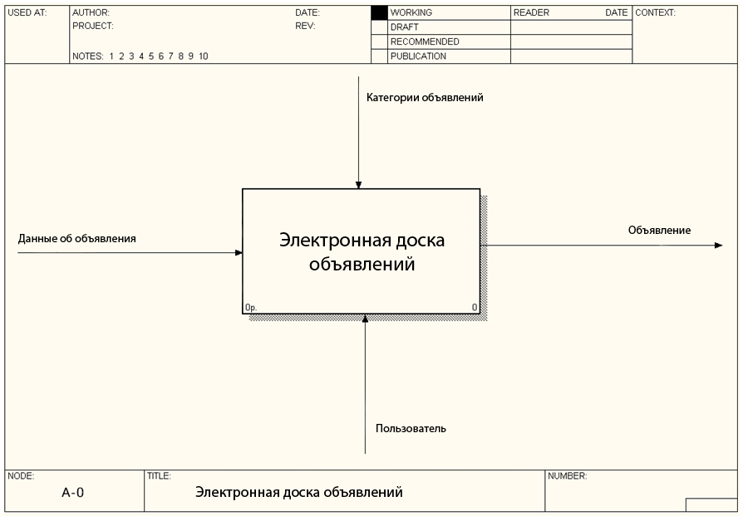
Рисунок А.1 – Основной процесс

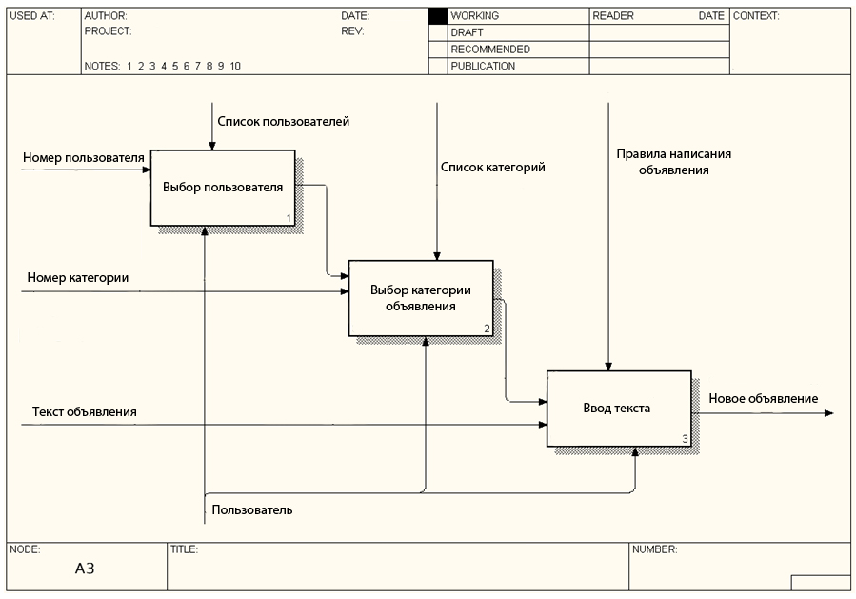
Рисунок А.2 – Декомпозиция основного процесса

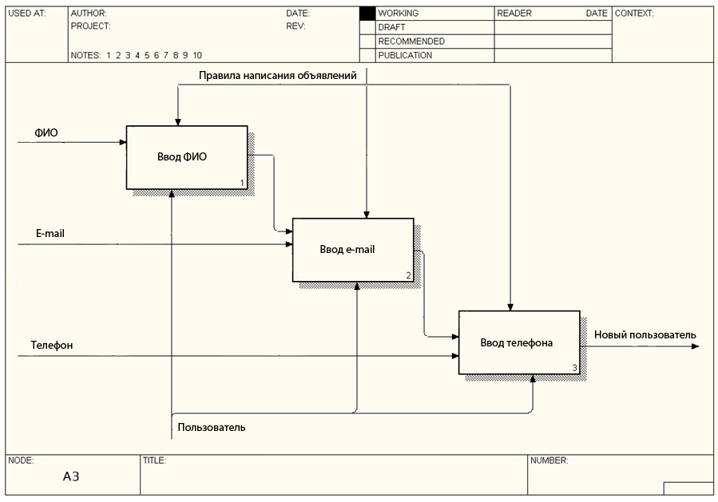
Рисунок А.3 – Декомпозиция второго уровня

Приложение Б
(обязательное)
Диаграмма вариантов использования

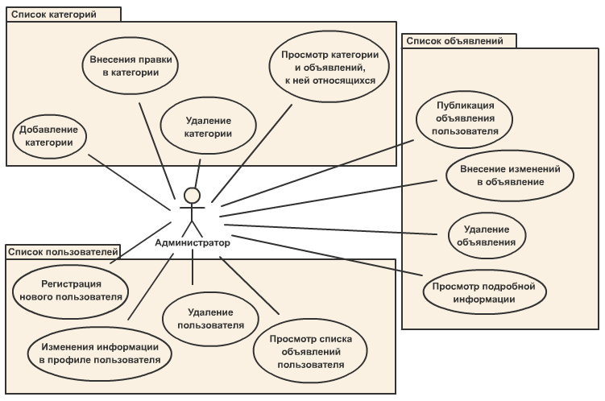

Приложение В
(обязательное)
Диаграмма состояний клиентской части

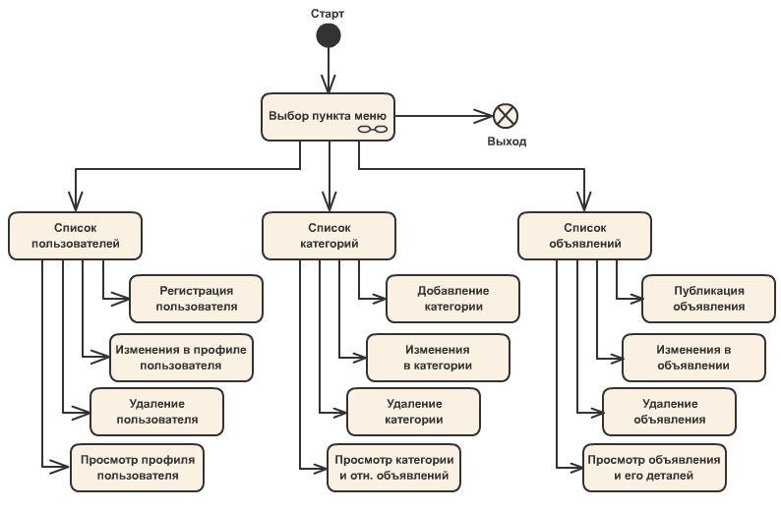

Приложение Г
(обязательное)
Диаграмма последовательностей

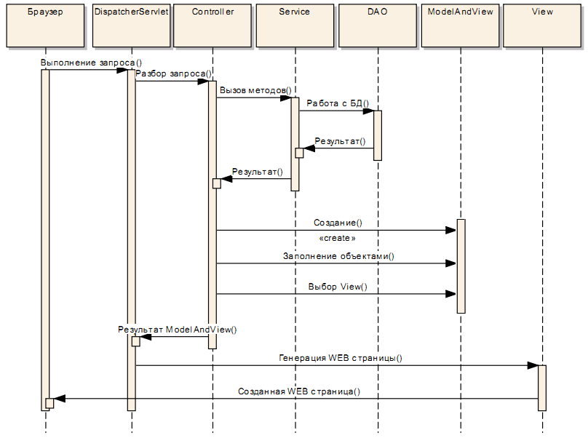

Приложение Д
(обязательное)
Диаграмма классов

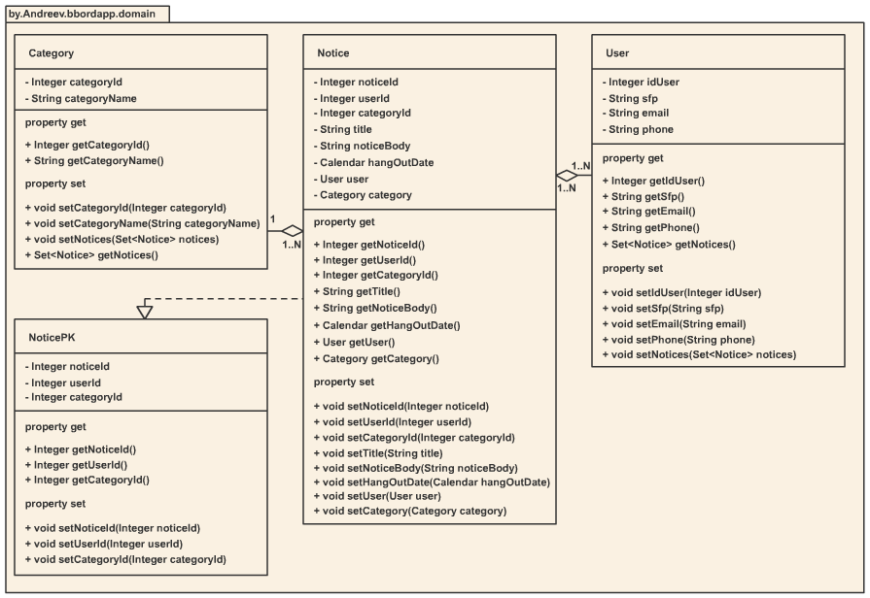

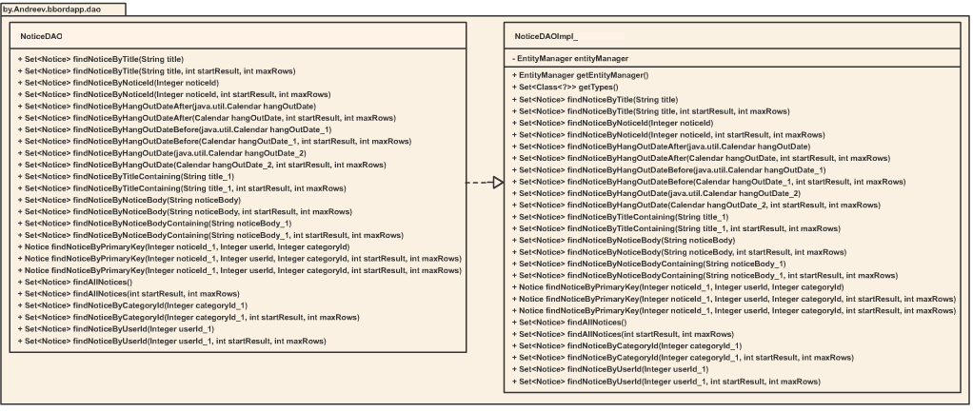
продолжение диаграммы Д
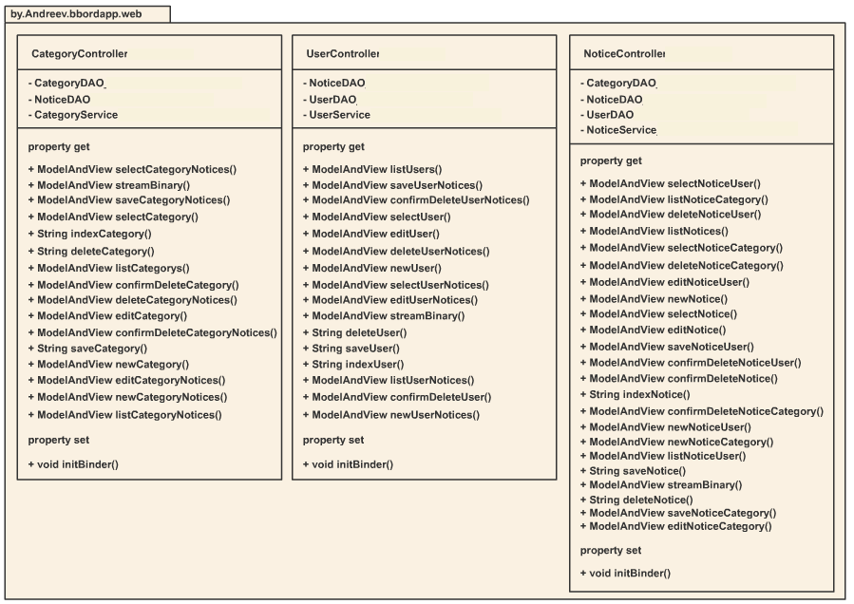

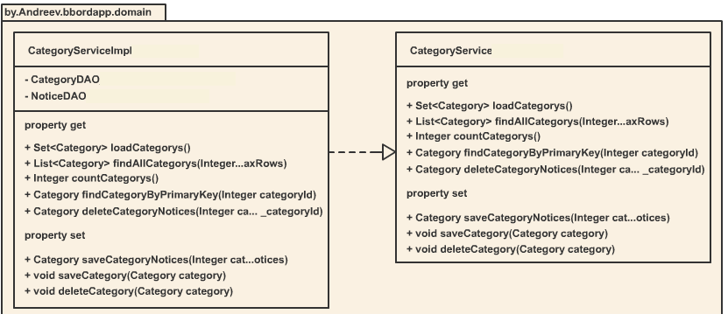

Приложение Е
(обязательное)
Диаграмма компонентов

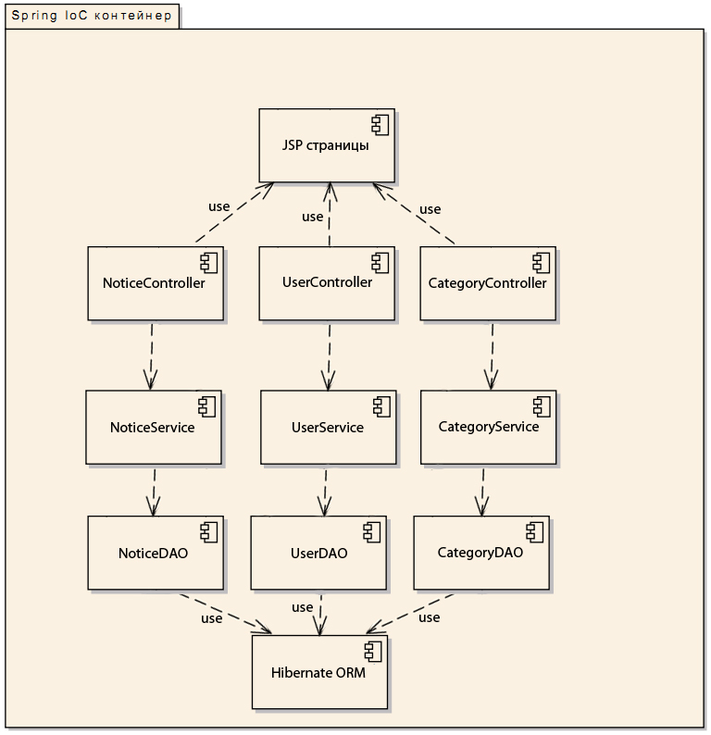

Приложение Ж
(обязательное)
Диаграмма развертывания

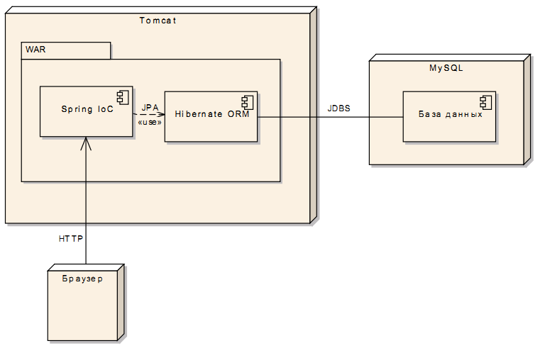

Приложение З
(обязательное)
Информационная модель

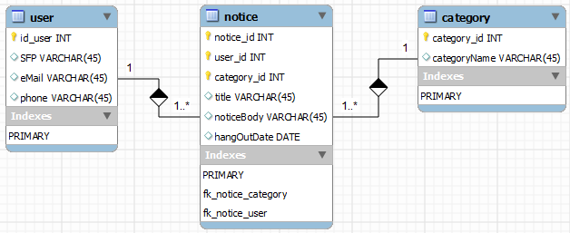

Приложение И
(обязательное)
Блок-схемы алгоритмов, реализующих бизнес-логику

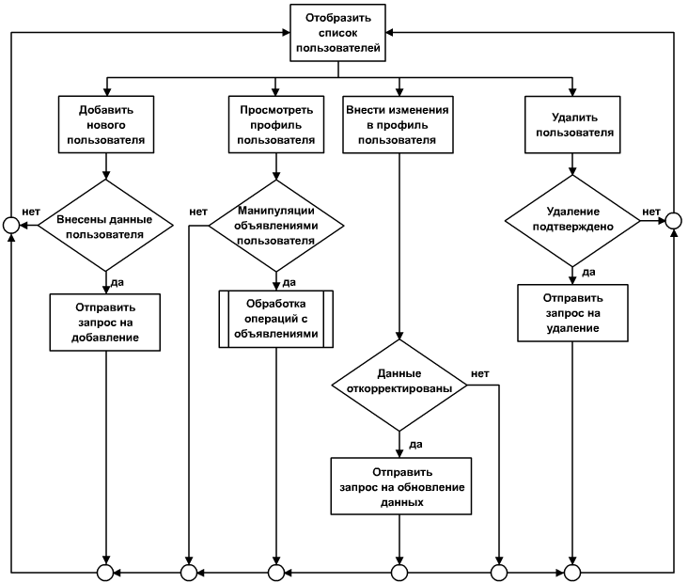

Приложение К
(обязательное)
Листинг алгоритмов реализующих бизнес-логику

CategoryServiceImpl_.java

package by.bbordapp.service;

import by.bbordapp.dao.CategoryDAO_;
import by.bbordapp.dao.NoticeDAO_;
import by.bbordapp.domain.Category;
import by.bbordapp.domain.Notice;
import java.util.List;
import java.util.Set;
import org.springframework.beans.factory.annotation.Autowired;
import org.springframework.stereotype.Service;
import org.springframework.transaction.annotation.Transactional;

/**
* Spring service that handles CRUD requests for Category entities
* @author LaBestia
*/

@Service("CategoryService")
@Transactional
public class CategoryServiceImpl_ implements CategoryService_ {

@Autowired
private CategoryDAO_ categoryDAO;

@Autowired
private NoticeDAO_ noticeDAO;

public CategoryServiceImpl_() {
}

@Transactional
public Category saveCategoryNotices(Integer categoryId, Notice related_notices) {
Category category = categoryDAO.findCategoryByPrimaryKey(categoryId, -1, -1);
Notice existingnotices = noticeDAO.findNoticeByPrimaryKey(related_notices.getNoticeId(), related_notices.getUserId(), related_notices.getCategoryId());

// copy into the existing record to preserve existing relationships
if (existingnotices != null) {
existingnotices.setNoticeId(related_notices.getNoticeId());
existingnotices.setUserId(related_notices.getUserId());
existingnotices.setCategoryId(related_notices.getCategoryId());
existingnotices.setTitle(related_notices.getTitle());
existingnotices.setNoticeBody(related_notices.getNoticeBody());
existingnotices.setHangOutDate(related_notices.getHangOutDate());
related_notices = existingnotices;
}

related_notices.setCategory(category);
category.getNotices().add(related_notices);
related_notices = noticeDAO.store(related_notices);
noticeDAO.flush();

category = categoryDAO.store(category);
categoryDAO.flush();

return category;
}

@Transactional
public Set<Category> loadCategorys() {
return categoryDAO.findAllCategorys();
}

@Transactional
public void saveCategory(Category category) {
Category existingCategory = categoryDAO.findCategoryByPrimaryKey(category.getCategoryId());

if (existingCategory != null) {
if (existingCategory != category) {
existingCategory.setCategoryId(category.getCategoryId());
existingCategory.setCategoryName(category.getCategoryName());
}
category = categoryDAO.store(existingCategory);
} else {
category = categoryDAO.store(category);
}
categoryDAO.flush();
}

@Transactional
public List<Category> findAllCategorys(Integer startResult, Integer maxRows) {
return new java.util.ArrayList<Category>(categoryDAO.findAllCategorys(startResult, maxRows));
}

@Transactional
public void deleteCategory(Category category) {
categoryDAO.remove(category);
categoryDAO.flush();
}

@Transactional
public Integer countCategorys() {
return ((Long) categoryDAO.createQuerySingleResult("select count(o) from Category o").getSingleResult()).intValue();
}

@Transactional
public Category findCategoryByPrimaryKey(Integer categoryId) {
return categoryDAO.findCategoryByPrimaryKey(categoryId);
}

@Transactional
public Category deleteCategoryNotices(Integer category_categoryId, Integer related_notices_noticeId, Integer related_notices_userId, Integer related_notices_categoryId) {
Notice related_notices = noticeDAO.findNoticeByPrimaryKey(related_notices_noticeId, related_notices_userId, related_notices_categoryId, -1, -1);

Category category = categoryDAO.findCategoryByPrimaryKey(category_categoryId, -1, -1);

related_notices.setCategory(null);
category.getNotices().remove(related_notices);

noticeDAO.remove(related_notices);
noticeDAO.flush();

return category;
}
}

NoticeServiceImpl_.java

package by.bbordapp.service;

import by.bbordapp.dao.CategoryDAO_;
import by.bbordapp.dao.NoticeDAO_;
import by.bbordapp.dao.UserDAO_;
import by.bbordapp.domain.Category;
import by.bbordapp.domain.Notice;
import by.bbordapp.domain.User;
import java.util.List;
import java.util.Set;
import org.springframework.beans.factory.annotation.Autowired;
import org.springframework.stereotype.Service;
import org.springframework.transaction.annotation.Transactional;

/**
* Spring service that handles CRUD requests for Notice entities
* @author LaBestia
*/

@Service("NoticeService")
@Transactional
public class NoticeServiceImpl_ implements NoticeService_ {

@Autowired
private CategoryDAO_ categoryDAO;

@Autowired
private NoticeDAO_ noticeDAO;

@Autowired
private UserDAO_ userDAO;

public NoticeServiceImpl_() {
}

@Transactional
public Notice deleteNoticeCategory(Integer notice_noticeId, Integer notice_userId, Integer notice_categoryId, Integer related_category_categoryId) {
Notice notice = noticeDAO.findNoticeByPrimaryKey(notice_noticeId, notice_userId, notice_categoryId, -1, -1);
Category related_category = categoryDAO.findCategoryByPrimaryKey(related_category_categoryId, -1, -1);

notice.setCategory(null);
related_category.getNotices().remove(notice);
notice = noticeDAO.store(notice);
noticeDAO.flush();

related_category = categoryDAO.store(related_category);
categoryDAO.flush();

categoryDAO.remove(related_category);
categoryDAO.flush();

return notice;
}

@Transactional
public Set<Notice> loadNotices() {
return noticeDAO.findAllNotices();
}

@Transactional
public void saveNotice(Notice notice) {
Notice existingNotice = noticeDAO.findNoticeByPrimaryKey(notice.getNoticeId(), notice.getUserId(), notice.getCategoryId());

if (existingNotice != null) {
if (existingNotice != notice) {
existingNotice.setNoticeId(notice.getNoticeId());
existingNotice.setUserId(notice.getUserId());
existingNotice.setCategoryId(notice.getCategoryId());
existingNotice.setTitle(notice.getTitle());
existingNotice.setNoticeBody(notice.getNoticeBody());
existingNotice.setHangOutDate(notice.getHangOutDate());
}
notice = noticeDAO.store(existingNotice);
} else {
notice = noticeDAO.store(notice);
}
noticeDAO.flush();
}

@Transactional
public void deleteNotice(Notice notice) {
noticeDAO.remove(notice);
noticeDAO.flush();
}

@Transactional
public Integer countNotices() {
return ((Long) noticeDAO.createQuerySingleResult("select count(*) from Notice o").getSingleResult()).intValue();
}

@Transactional
public List<Notice> findAllNotices(Integer startResult, Integer maxRows) {
return new java.util.ArrayList<Notice>(noticeDAO.findAllNotices(startResult, maxRows));
}

@Transactional
public Notice deleteNoticeUser(Integer notice_noticeId, Integer notice_userId, Integer notice_categoryId, Integer related_user_idUser) {
Notice notice = noticeDAO.findNoticeByPrimaryKey(notice_noticeId, notice_userId, notice_categoryId, -1, -1);
User related_user = userDAO.findUserByPrimaryKey(related_user_idUser, -1, -1);

notice.setUser(null);
related_user.getNotices().remove(notice);
notice = noticeDAO.store(notice);
noticeDAO.flush();

related_user = userDAO.store(related_user);
userDAO.flush();

userDAO.remove(related_user);
userDAO.flush();

return notice;
}

@Transactional
public Notice saveNoticeUser(Integer noticeId, Integer userId, Integer categoryId, User related_user) {
Notice notice = noticeDAO.findNoticeByPrimaryKey(noticeId, userId, categoryId, -1, -1);
User existinguser = userDAO.findUserByPrimaryKey(related_user.getIdUser());

// copy into the existing record to preserve existing relationships
if (existinguser != null) {
existinguser.setIdUser(related_user.getIdUser());
existinguser.setSfp(related_user.getSfp());
existinguser.setEmail(related_user.getEmail());
existinguser.setPhone(related_user.getPhone());
related_user = existinguser;
}

notice.setUser(related_user);
related_user.getNotices().add(notice);
notice = noticeDAO.store(notice);
noticeDAO.flush();

related_user = userDAO.store(related_user);
userDAO.flush();

return notice;
}

@Transactional
public Notice saveNoticeCategory(Integer noticeId, Integer userId, Integer categoryId, Category related_category) {
Notice notice = noticeDAO.findNoticeByPrimaryKey(noticeId, userId, categoryId, -1, -1);
Category existingcategory = categoryDAO.findCategoryByPrimaryKey(related_category.getCategoryId());

// copy into the existing record to preserve existing relationships
if (existingcategory != null) {
existingcategory.setCategoryId(related_category.getCategoryId());
existingcategory.setCategoryName(related_category.getCategoryName());
related_category = existingcategory;
}

notice.setCategory(related_category);
related_category.getNotices().add(notice);
notice = noticeDAO.store(notice);
noticeDAO.flush();

related_category = categoryDAO.store(related_category);
categoryDAO.flush();

return notice;
}

@Transactional
public Notice findNoticeByPrimaryKey(Integer noticeId, Integer userId, Integer categoryId) {
return noticeDAO.findNoticeByPrimaryKey(noticeId, userId, categoryId);
}
}

UserServiceImpl_.java

package by.bbordapp.service;

import by.bbordapp.dao.NoticeDAO_;
import by.bbordapp.dao.UserDAO_;
import by.bbordapp.domain.Notice;
import by.bbordapp.domain.User;
import java.util.List;
import java.util.Set;
import org.springframework.beans.factory.annotation.Autowired;
import org.springframework.stereotype.Service;
import org.springframework.transaction.annotation.Transactional;

/**
* Spring service that handles CRUD requests for User entities
* @author LaBestia
*/

@Service("UserService")
@Transactional
public class UserServiceImpl_ implements UserService_ {

@Autowired
private NoticeDAO_ noticeDAO;

@Autowired
private UserDAO_ userDAO;

public UserServiceImpl_() {
}

@Transactional
public User findUserByPrimaryKey(Integer idUser) {
return userDAO.findUserByPrimaryKey(idUser);
}

@Transactional
public void saveUser(User user) {
User existingUser = userDAO.findUserByPrimaryKey(user.getIdUser());

if (existingUser != null) {
if (existingUser != user) {
existingUser.setIdUser(user.getIdUser());
existingUser.setSfp(user.getSfp());
existingUser.setEmail(user.getEmail());
existingUser.setPhone(user.getPhone());
}
user = userDAO.store(existingUser);
} else {
user = userDAO.store(user);
}
userDAO.flush();
}

@Transactional
public void deleteUser(User user) {
userDAO.remove(user);
userDAO.flush();
}

@Transactional
public List<User> findAllUsers(Integer startResult, Integer maxRows) {
return new java.util.ArrayList<User>(userDAO.findAllUsers(startResult, maxRows));
}

@Transactional
public Integer countUsers() {
return ((Long) userDAO.createQuerySingleResult("select count(o) from User o").getSingleResult()).intValue();
}

@Transactional
public User saveUserNotices(Integer idUser, Notice related_notices) {
User user = userDAO.findUserByPrimaryKey(idUser, -1, -1);
Notice existingnotices = noticeDAO.findNoticeByPrimaryKey(related_notices.getNoticeId(), related_notices.getUserId(), related_notices.getCategoryId());

// copy into the existing record to preserve existing relationships
if (existingnotices != null) {
existingnotices.setNoticeId(related_notices.getNoticeId());
existingnotices.setUserId(related_notices.getUserId());
existingnotices.setCategoryId(related_notices.getCategoryId());
existingnotices.setTitle(related_notices.getTitle());
existingnotices.setNoticeBody(related_notices.getNoticeBody());
existingnotices.setHangOutDate(related_notices.getHangOutDate());
related_notices = existingnotices;
}

related_notices.setUser(user);
user.getNotices().add(related_notices);
related_notices = noticeDAO.store(related_notices);
noticeDAO.flush();

user = userDAO.store(user);
userDAO.flush();

return user;
}

@Transactional
public User deleteUserNotices(Integer user_idUser, Integer related_notices_noticeId, Integer related_notices_userId, Integer related_notices_categoryId) {
Notice related_notices = noticeDAO.findNoticeByPrimaryKey(related_notices_noticeId, related_notices_userId, related_notices_categoryId, -1, -1);

User user = userDAO.findUserByPrimaryKey(user_idUser, -1, -1);

related_notices.setUser(null);
user.getNotices().remove(related_notices);

noticeDAO.remove(related_notices);
noticeDAO.flush();

return user;
}

@Transactional
public Set<User> loadUsers() {
return userDAO.findAllUsers();
}
}

Приложение Л
(обязательное)
Листинг основных элементов программы

CategoryController_.java

package by.bbordapp.web;

import by.bbordapp.dao.CategoryDAO_;
import by.bbordapp.dao.NoticeDAO_;
import by.bbordapp.domain.Category;
import by.bbordapp.domain.Notice;
import by.bbordapp.service.CategoryService_;
import javax.servlet.http.HttpServletRequest;
import javax.servlet.http.HttpServletResponse;
import org.springframework.beans.factory.annotation.Autowired;
import org.springframework.stereotype.Controller;
import org.springframework.web.bind.WebDataBinder;
import org.springframework.web.bind.annotation.InitBinder;
import org.springframework.web.bind.annotation.ModelAttribute;
import org.springframework.web.bind.annotation.RequestMapping;
import org.springframework.web.bind.annotation.RequestParam;
import org.springframework.web.servlet.ModelAndView;

/**
* Spring MVC controller that handles CRUD requests for Category entities
* @author LaBestia
*/

@Controller("CategoryController")
public class CategoryController_ {

@Autowired
private CategoryDAO_ categoryDAO;

@Autowired
private NoticeDAO_ noticeDAO;

@Autowired
private CategoryService_ categoryService;

@InitBinder
public void initBinder(WebDataBinder binder, HttpServletRequest request) { // Register static property editors.
binder.registerCustomEditor(java.util.Calendar.class, new org.skyway.spring.util.databinding.CustomCalendarEditor());
binder.registerCustomEditor(byte[].class, new org.springframework.web.multipart.support.ByteArrayMultipartFileEditor());
binder.registerCustomEditor(boolean.class, new org.skyway.spring.util.databinding.EnhancedBooleanEditor(false));
binder.registerCustomEditor(Boolean.class, new org.skyway.spring.util.databinding.EnhancedBooleanEditor(true));
binder.registerCustomEditor(java.math.BigDecimal.class, new org.skyway.spring.util.databinding.NaNHandlingNumberEditor(java.math.BigDecimal.class, true));
binder.registerCustomEditor(Integer.class, new org.skyway.spring.util.databinding.NaNHandlingNumberEditor(Integer.class, true));
binder.registerCustomEditor(java.util.Date.class, new org.skyway.spring.util.databinding.CustomDateEditor());
binder.registerCustomEditor(String.class, new org.skyway.spring.util.databinding.StringEditor());
binder.registerCustomEditor(Long.class, new org.skyway.spring.util.databinding.NaNHandlingNumberEditor(Long.class, true));
binder.registerCustomEditor(Double.class, new org.skyway.spring.util.databinding.NaNHandlingNumberEditor(Double.class, true));
}

@RequestMapping("/selectCategoryNotices")
public ModelAndView selectCategoryNotices(@RequestParam Integer category_categoryId, @RequestParam Integer notices_noticeId, @RequestParam Integer notices_userId, @RequestParam Integer notices_categoryId) {
Notice notice = noticeDAO.findNoticeByPrimaryKey(notices_noticeId, notices_userId, notices_categoryId, -1, -1);

ModelAndView mav = new ModelAndView();
mav.addObject("category_categoryId", category_categoryId);
mav.addObject("notice", notice);
mav.setViewName("category/notices/viewNotices.jsp");

return mav;
}

@RequestMapping("/categoryController/binary.action")
public ModelAndView streamBinary(@ModelAttribute HttpServletRequest request, @ModelAttribute HttpServletResponse response) {
ModelAndView mav = new ModelAndView();
mav.setViewName("streamedBinaryContentView");
return mav;

}

@RequestMapping("/saveCategoryNotices")
public ModelAndView saveCategoryNotices(@RequestParam Integer category_categoryId, @ModelAttribute Notice notices) {
Category parent_category = categoryService.saveCategoryNotices(category_categoryId, notices);

ModelAndView mav = new ModelAndView();
mav.addObject("category_categoryId", category_categoryId);
mav.addObject("category", parent_category);
mav.setViewName("category/viewCategory.jsp");

return mav;
}

@RequestMapping("/selectCategory")
public ModelAndView selectCategory(@RequestParam Integer categoryIdKey) {
ModelAndView mav = new ModelAndView();

mav.addObject("category", categoryDAO.findCategoryByPrimaryKey(categoryIdKey));
mav.setViewName("category/viewCategory.jsp");

return mav;
}

public String indexCategory() {
return "redirect:/indexCategory";
}

@RequestMapping("/deleteCategory")
public String deleteCategory(@RequestParam Integer categoryIdKey) {
Category category = categoryDAO.findCategoryByPrimaryKey(categoryIdKey);
categoryService.deleteCategory(category);
return "forward:/indexCategory";
}

@RequestMapping("/indexCategory")
public ModelAndView listCategorys() {
ModelAndView mav = new ModelAndView();

mav.addObject("categorys", categoryService.loadCategorys());

mav.setViewName("category/listCategorys.jsp");

return mav;
}

@RequestMapping("/confirmDeleteCategory")
public ModelAndView confirmDeleteCategory(@RequestParam Integer categoryIdKey) {
ModelAndView mav = new ModelAndView();

mav.addObject("category", categoryDAO.findCategoryByPrimaryKey(categoryIdKey));
mav.setViewName("category/deleteCategory.jsp");

return mav;
}

@RequestMapping("/deleteCategoryNotices")
public ModelAndView deleteCategoryNotices(@RequestParam Integer category_categoryId, @RequestParam Integer related_notices_noticeId, @RequestParam Integer related_notices_userId, @RequestParam Integer related_notices_categoryId) {
ModelAndView mav = new ModelAndView();

Category category = categoryService.deleteCategoryNotices(category_categoryId, related_notices_noticeId, related_notices_userId, related_notices_categoryId);

mav.addObject("category_categoryId", category_categoryId);
mav.addObject("category", category);
mav.setViewName("category/viewCategory.jsp");

return mav;
}

@RequestMapping("/editCategory")
public ModelAndView editCategory(@RequestParam Integer categoryIdKey) {
ModelAndView mav = new ModelAndView();

mav.addObject("category", categoryDAO.findCategoryByPrimaryKey(categoryIdKey));
mav.setViewName("category/editCategory.jsp");

return mav;
}

@RequestMapping("/confirmDeleteCategoryNotices")
public ModelAndView confirmDeleteCategoryNotices(@RequestParam Integer category_categoryId, @RequestParam Integer related_notices_noticeId, @RequestParam Integer related_notices_userId, @RequestParam Integer related_notices_categoryId) {
ModelAndView mav = new ModelAndView();

mav.addObject("notice", noticeDAO.findNoticeByPrimaryKey(related_notices_noticeId, related_notices_userId, related_notices_categoryId));
mav.addObject("category_categoryId", category_categoryId);
mav.setViewName("category/notices/deleteNotices.jsp");

return mav;
}

@RequestMapping("/saveCategory")
public String saveCategory(@ModelAttribute Category category) {
categoryService.saveCategory(category);
return "forward:/indexCategory";
}

@RequestMapping("/newCategory")
public ModelAndView newCategory() {
ModelAndView mav = new ModelAndView();

mav.addObject("category", new Category());
mav.addObject("newFlag", true);
mav.setViewName("category/editCategory.jsp");

return mav;
}

@RequestMapping("/editCategoryNotices")
public ModelAndView editCategoryNotices(@RequestParam Integer category_categoryId, @RequestParam Integer notices_noticeId, @RequestParam Integer notices_userId, @RequestParam Integer notices_categoryId) {
Notice notice = noticeDAO.findNoticeByPrimaryKey(notices_noticeId, notices_userId, notices_categoryId, -1, -1);

ModelAndView mav = new ModelAndView();
mav.addObject("category_categoryId", category_categoryId);
mav.addObject("notice", notice);
mav.setViewName("category/notices/editNotices.jsp");

return mav;
}

@RequestMapping("/newCategoryNotices")
public ModelAndView newCategoryNotices(@RequestParam Integer category_categoryId) {
ModelAndView mav = new ModelAndView();
mav.addObject("category_categoryId", category_categoryId);
mav.addObject("notice", new Notice());
mav.addObject("newFlag", true);
mav.setViewName("category/notices/editNotices.jsp");

return mav;
}

@RequestMapping("/listCategoryNotices")
public ModelAndView listCategoryNotices(@RequestParam Integer categoryIdKey) {
ModelAndView mav = new ModelAndView();

mav.addObject("category", categoryDAO.findCategoryByPrimaryKey(categoryIdKey));
mav.setViewName("category/notices/listNotices.jsp");

return mav;
}
}

NoticeController_.java

package by.bbordapp.web;

import by.bbordapp.dao.CategoryDAO_;
import by.bbordapp.dao.NoticeDAO_;
import by.bbordapp.dao.UserDAO_;
import by.bbordapp.domain.Category;
import by.bbordapp.domain.Notice;
import by.bbordapp.domain.User;
import by.bbordapp.service.NoticeService_;
import javax.servlet.http.HttpServletRequest;
import javax.servlet.http.HttpServletResponse;
import org.springframework.beans.factory.annotation.Autowired;
import org.springframework.stereotype.Controller;
import org.springframework.web.bind.WebDataBinder;
import org.springframework.web.bind.annotation.InitBinder;
import org.springframework.web.bind.annotation.ModelAttribute;
import org.springframework.web.bind.annotation.RequestMapping;
import org.springframework.web.bind.annotation.RequestParam;
import org.springframework.web.servlet.ModelAndView;

/**
* Spring MVC controller that handles CRUD requests for Notice entities
* @author LaBestia
*/

@Controller("NoticeController")
public class NoticeController_ {

@Autowired
private CategoryDAO_ categoryDAO;

@Autowired
private NoticeDAO_ noticeDAO;

@Autowired
private UserDAO_ userDAO;

@Autowired
private NoticeService_ noticeService;

@RequestMapping("/selectNoticeUser")
public ModelAndView selectNoticeUser(@RequestParam Integer notice_noticeId, @RequestParam Integer notice_userId, @RequestParam Integer notice_categoryId, @RequestParam Integer user_idUser) {
User user = userDAO.findUserByPrimaryKey(user_idUser, -1, -1);

ModelAndView mav = new ModelAndView();
mav.addObject("notice_noticeId", notice_noticeId);
mav.addObject("notice_userId", notice_userId);
mav.addObject("notice_categoryId", notice_categoryId);
mav.addObject("user", user);
mav.setViewName("notice/user/viewUser.jsp");

return mav;
}

@RequestMapping("/listNoticeCategory")
public ModelAndView listNoticeCategory(@RequestParam Integer noticeIdKey, @RequestParam Integer userIdKey, @RequestParam Integer categoryIdKey) {
ModelAndView mav = new ModelAndView();

mav.addObject("notice", noticeDAO.findNoticeByPrimaryKey(noticeIdKey, userIdKey, categoryIdKey));
mav.setViewName("notice/category/listCategory.jsp");

return mav;
}

@RequestMapping("/deleteNoticeUser")
public ModelAndView deleteNoticeUser(@RequestParam Integer notice_noticeId, @RequestParam Integer notice_userId, @RequestParam Integer notice_categoryId, @RequestParam Integer related_user_idUser) {
ModelAndView mav = new ModelAndView();

Notice notice = noticeService.deleteNoticeUser(notice_noticeId, notice_userId, notice_categoryId, related_user_idUser);

mav.addObject("notice_noticeId", notice_noticeId);
mav.addObject("notice_userId", notice_userId);
mav.addObject("notice_categoryId", notice_categoryId);
mav.addObject("notice", notice);
mav.setViewName("notice/viewNotice.jsp");

return mav;
}

@RequestMapping("/indexNotice")
public ModelAndView listNotices() {
ModelAndView mav = new ModelAndView();

mav.addObject("notices", noticeService.loadNotices());

mav.setViewName("notice/listNotices.jsp");

return mav;
}

@InitBinder
public void initBinder(WebDataBinder binder, HttpServletRequest request) { // Register static property editors.
binder.registerCustomEditor(java.util.Calendar.class, new org.skyway.spring.util.databinding.CustomCalendarEditor());
binder.registerCustomEditor(byte[].class, new org.springframework.web.multipart.support.ByteArrayMultipartFileEditor());
binder.registerCustomEditor(boolean.class, new org.skyway.spring.util.databinding.EnhancedBooleanEditor(false));
binder.registerCustomEditor(Boolean.class, new org.skyway.spring.util.databinding.EnhancedBooleanEditor(true));
binder.registerCustomEditor(java.math.BigDecimal.class, new org.skyway.spring.util.databinding.NaNHandlingNumberEditor(java.math.BigDecimal.class, true));
binder.registerCustomEditor(Integer.class, new org.skyway.spring.util.databinding.NaNHandlingNumberEditor(Integer.class, true));
binder.registerCustomEditor(java.util.Date.class, new org.skyway.spring.util.databinding.CustomDateEditor());
binder.registerCustomEditor(String.class, new org.skyway.spring.util.databinding.StringEditor());
binder.registerCustomEditor(Long.class, new org.skyway.spring.util.databinding.NaNHandlingNumberEditor(Long.class, true));
binder.registerCustomEditor(Double.class, new org.skyway.spring.util.databinding.NaNHandlingNumberEditor(Double.class, true));
}

@RequestMapping("/selectNoticeCategory")
public ModelAndView selectNoticeCategory(@RequestParam Integer notice_noticeId, @RequestParam Integer notice_userId, @RequestParam Integer notice_categoryId, @RequestParam Integer category_categoryId) {
Category category = categoryDAO.findCategoryByPrimaryKey(category_categoryId, -1, -1);

ModelAndView mav = new ModelAndView();
mav.addObject("notice_noticeId", notice_noticeId);
mav.addObject("notice_userId", notice_userId);
mav.addObject("notice_categoryId", notice_categoryId);
mav.addObject("category", category);
mav.setViewName("notice/category/viewCategory.jsp");

return mav;
}

@RequestMapping("/deleteNoticeCategory")
public ModelAndView deleteNoticeCategory(@RequestParam Integer notice_noticeId, @RequestParam Integer notice_userId, @RequestParam Integer notice_categoryId, @RequestParam Integer related_category_categoryId) {
ModelAndView mav = new ModelAndView();

Notice notice = noticeService.deleteNoticeCategory(notice_noticeId, notice_userId, notice_categoryId, related_category_categoryId);

mav.addObject("notice_noticeId", notice_noticeId);
mav.addObject("notice_userId", notice_userId);
mav.addObject("notice_categoryId", notice_categoryId);
mav.addObject("notice", notice);
mav.setViewName("notice/viewNotice.jsp");

return mav;
}

@RequestMapping("/editNoticeUser")
public ModelAndView editNoticeUser(@RequestParam Integer notice_noticeId, @RequestParam Integer notice_userId, @RequestParam Integer notice_categoryId, @RequestParam Integer user_idUser) {
User user = userDAO.findUserByPrimaryKey(user_idUser, -1, -1);

ModelAndView mav = new ModelAndView();
mav.addObject("notice_noticeId", notice_noticeId);
mav.addObject("notice_userId", notice_userId);
mav.addObject("notice_categoryId", notice_categoryId);
mav.addObject("user", user);
mav.setViewName("notice/user/editUser.jsp");

return mav;
}

@RequestMapping("/newNotice")
public ModelAndView newNotice() {
ModelAndView mav = new ModelAndView();

mav.addObject("notice", new Notice());
mav.addObject("newFlag", true);
mav.setViewName("notice/editNotice.jsp");

return mav;
}

@RequestMapping("/selectNotice")
public ModelAndView selectNotice(@RequestParam Integer noticeIdKey, @RequestParam Integer userIdKey, @RequestParam Integer categoryIdKey) {
ModelAndView mav = new ModelAndView();

mav.addObject("notice", noticeDAO.findNoticeByPrimaryKey(noticeIdKey, userIdKey, categoryIdKey));
mav.setViewName("notice/viewNotice.jsp");

return mav;
}

@RequestMapping("/editNotice")
public ModelAndView editNotice(@RequestParam Integer noticeIdKey, @RequestParam Integer userIdKey, @RequestParam Integer categoryIdKey) {
ModelAndView mav = new ModelAndView();

mav.addObject("notice", noticeDAO.findNoticeByPrimaryKey(noticeIdKey, userIdKey, categoryIdKey));
mav.setViewName("notice/editNotice.jsp");

return mav;
}

@RequestMapping("/saveNoticeUser")
public ModelAndView saveNoticeUser(@RequestParam Integer notice_noticeId, @RequestParam Integer notice_userId, @RequestParam Integer notice_categoryId, @ModelAttribute User user) {
Notice parent_notice = noticeService.saveNoticeUser(notice_noticeId, notice_userId, notice_categoryId, user);

ModelAndView mav = new ModelAndView();
mav.addObject("notice_noticeId", notice_noticeId);
mav.addObject("notice_userId", notice_userId);
mav.addObject("notice_categoryId", notice_categoryId);
mav.addObject("notice", parent_notice);
mav.setViewName("notice/viewNotice.jsp");

return mav;
}

@RequestMapping("/confirmDeleteNoticeUser")
public ModelAndView confirmDeleteNoticeUser(@RequestParam Integer notice_noticeId, @RequestParam Integer notice_userId, @RequestParam Integer notice_categoryId, @RequestParam Integer related_user_idUser) {
ModelAndView mav = new ModelAndView();

mav.addObject("user", userDAO.findUserByPrimaryKey(related_user_idUser));
mav.addObject("notice_noticeId", notice_noticeId);
mav.addObject("notice_userId", notice_userId);
mav.addObject("notice_categoryId", notice_categoryId);
mav.setViewName("notice/user/deleteUser.jsp");

return mav;
}

@RequestMapping("/confirmDeleteNotice")
public ModelAndView confirmDeleteNotice(@RequestParam Integer noticeIdKey, @RequestParam Integer userIdKey, @RequestParam Integer categoryIdKey) {
ModelAndView mav = new ModelAndView();

mav.addObject("notice", noticeDAO.findNoticeByPrimaryKey(noticeIdKey, userIdKey, categoryIdKey));
mav.setViewName("notice/deleteNotice.jsp");

return mav;
}

public String indexNotice() {
return "redirect:/indexNotice";
}

@RequestMapping("/confirmDeleteNoticeCategory")
public ModelAndView confirmDeleteNoticeCategory(@RequestParam Integer notice_noticeId, @RequestParam Integer notice_userId, @RequestParam Integer notice_categoryId, @RequestParam Integer related_category_categoryId) {
ModelAndView mav = new ModelAndView();

mav.addObject("category", categoryDAO.findCategoryByPrimaryKey(related_category_categoryId));
mav.addObject("notice_noticeId", notice_noticeId);
mav.addObject("notice_userId", notice_userId);
mav.addObject("notice_categoryId", notice_categoryId);
mav.setViewName("notice/category/deleteCategory.jsp");

return mav;
}

@RequestMapping("/newNoticeUser")
public ModelAndView newNoticeUser(@RequestParam Integer notice_noticeId, @RequestParam Integer notice_userId, @RequestParam Integer notice_categoryId) {
ModelAndView mav = new ModelAndView();
mav.addObject("notice_noticeId", notice_noticeId);
mav.addObject("notice_userId", notice_userId);
mav.addObject("notice_categoryId", notice_categoryId);
mav.addObject("user", new User());
mav.addObject("newFlag", true);
mav.setViewName("notice/user/editUser.jsp");

return mav;
}

@RequestMapping("/newNoticeCategory")
public ModelAndView newNoticeCategory(@RequestParam Integer notice_noticeId, @RequestParam Integer notice_userId, @RequestParam Integer notice_categoryId) {
ModelAndView mav = new ModelAndView();
mav.addObject("notice_noticeId", notice_noticeId);
mav.addObject("notice_userId", notice_userId);
mav.addObject("notice_categoryId", notice_categoryId);
mav.addObject("category", new Category());
mav.addObject("newFlag", true);
mav.setViewName("notice/category/editCategory.jsp");

return mav;
}

@RequestMapping("/listNoticeUser")
public ModelAndView listNoticeUser(@RequestParam Integer noticeIdKey, @RequestParam Integer userIdKey, @RequestParam Integer categoryIdKey) {
ModelAndView mav = new ModelAndView();

mav.addObject("notice", noticeDAO.findNoticeByPrimaryKey(noticeIdKey, userIdKey, categoryIdKey));
mav.setViewName("notice/user/listUser.jsp");

return mav;
}

@RequestMapping("/saveNotice")
public String saveNotice(@ModelAttribute Notice notice) {
noticeService.saveNotice(notice);
return "forward:/indexNotice";
}

@RequestMapping("/noticeController/binary.action")
public ModelAndView streamBinary(@ModelAttribute HttpServletRequest request, @ModelAttribute HttpServletResponse response) {
ModelAndView mav = new ModelAndView();
mav.setViewName("streamedBinaryContentView");
return mav;

}

@RequestMapping("/deleteNotice")
public String deleteNotice(@RequestParam Integer noticeIdKey, @RequestParam Integer userIdKey, @RequestParam Integer categoryIdKey) {
Notice notice = noticeDAO.findNoticeByPrimaryKey(noticeIdKey, userIdKey, categoryIdKey);
noticeService.deleteNotice(notice);
return "forward:/indexNotice";
}

@RequestMapping("/saveNoticeCategory")
public ModelAndView saveNoticeCategory(@RequestParam Integer notice_noticeId, @RequestParam Integer notice_userId, @RequestParam Integer notice_categoryId, @ModelAttribute Category category) {
Notice parent_notice = noticeService.saveNoticeCategory(notice_noticeId, notice_userId, notice_categoryId, category);

ModelAndView mav = new ModelAndView();
mav.addObject("notice_noticeId", notice_noticeId);
mav.addObject("notice_userId", notice_userId);
mav.addObject("notice_categoryId", notice_categoryId);
mav.addObject("notice", parent_notice);
mav.setViewName("notice/viewNotice.jsp");

return mav;
}

@RequestMapping("/editNoticeCategory")
public ModelAndView editNoticeCategory(@RequestParam Integer notice_noticeId, @RequestParam Integer notice_userId, @RequestParam Integer notice_categoryId, @RequestParam Integer category_categoryId) {
Category category = categoryDAO.findCategoryByPrimaryKey(category_categoryId, -1, -1);

ModelAndView mav = new ModelAndView();
mav.addObject("notice_noticeId", notice_noticeId);
mav.addObject("notice_userId", notice_userId);
mav.addObject("notice_categoryId", notice_categoryId);
mav.addObject("category", category);
mav.setViewName("notice/category/editCategory.jsp");

return mav;
}
}

UserController_.java

package by.bbordapp.web;

import by.bbordapp.dao.NoticeDAO_;
import by.bbordapp.dao.UserDAO_;
import by.bbordapp.domain.Notice;
import by.bbordapp.domain.User;
import by.bbordapp.service.UserService_;
import javax.servlet.http.HttpServletRequest;
import javax.servlet.http.HttpServletResponse;
import org.springframework.beans.factory.annotation.Autowired;
import org.springframework.stereotype.Controller;
import org.springframework.web.bind.WebDataBinder;
import org.springframework.web.bind.annotation.InitBinder;
import org.springframework.web.bind.annotation.ModelAttribute;
import org.springframework.web.bind.annotation.RequestMapping;
import org.springframework.web.bind.annotation.RequestParam;
import org.springframework.web.servlet.ModelAndView;

/**
* Spring MVC controller that handles CRUD requests for User entities
* @author LaBestia
*/

@Controller("UserController")
public class UserController_ {

@Autowired
private NoticeDAO_ noticeDAO;

@Autowired
private UserDAO_ userDAO;

@Autowired
private UserService_ userService;

@RequestMapping("/indexUser")
public ModelAndView listUsers() {
ModelAndView mav = new ModelAndView();

mav.addObject("users", userService.loadUsers());

mav.setViewName("user/listUsers.jsp");

return mav;
}

@RequestMapping("/saveUserNotices")
public ModelAndView saveUserNotices(@RequestParam Integer user_idUser, @ModelAttribute Notice notices) {
User parent_user = userService.saveUserNotices(user_idUser, notices);

ModelAndView mav = new ModelAndView();
mav.addObject("user_idUser", user_idUser);
mav.addObject("user", parent_user);
mav.setViewName("user/viewUser.jsp");

return mav;
}

@RequestMapping("/confirmDeleteUserNotices")
public ModelAndView confirmDeleteUserNotices(@RequestParam Integer user_idUser, @RequestParam Integer related_notices_noticeId, @RequestParam Integer related_notices_userId, @RequestParam Integer related_notices_categoryId) {
ModelAndView mav = new ModelAndView();

mav.addObject("notice", noticeDAO.findNoticeByPrimaryKey(related_notices_noticeId, related_notices_userId, related_notices_categoryId));
mav.addObject("user_idUser", user_idUser);
mav.setViewName("user/notices/deleteNotices.jsp");

return mav;
}

@InitBinder
public void initBinder(WebDataBinder binder, HttpServletRequest request) { // Register static property editors.
binder.registerCustomEditor(java.util.Calendar.class, new org.skyway.spring.util.databinding.CustomCalendarEditor());
binder.registerCustomEditor(byte[].class, new org.springframework.web.multipart.support.ByteArrayMultipartFileEditor());
binder.registerCustomEditor(boolean.class, new org.skyway.spring.util.databinding.EnhancedBooleanEditor(false));
binder.registerCustomEditor(Boolean.class, new org.skyway.spring.util.databinding.EnhancedBooleanEditor(true));
binder.registerCustomEditor(java.math.BigDecimal.class, new org.skyway.spring.util.databinding.NaNHandlingNumberEditor(java.math.BigDecimal.class, true));
binder.registerCustomEditor(Integer.class, new org.skyway.spring.util.databinding.NaNHandlingNumberEditor(Integer.class, true));
binder.registerCustomEditor(java.util.Date.class, new org.skyway.spring.util.databinding.CustomDateEditor());
binder.registerCustomEditor(String.class, new org.skyway.spring.util.databinding.StringEditor());
binder.registerCustomEditor(Long.class, new org.skyway.spring.util.databinding.NaNHandlingNumberEditor(Long.class, true));
binder.registerCustomEditor(Double.class, new org.skyway.spring.util.databinding.NaNHandlingNumberEditor(Double.class, true));
}

@RequestMapping("/selectUser")
public ModelAndView selectUser(@RequestParam Integer idUserKey) {
ModelAndView mav = new ModelAndView();

mav.addObject("user", userDAO.findUserByPrimaryKey(idUserKey));
mav.setViewName("user/viewUser.jsp");

return mav;
}

@RequestMapping("/editUser")
public ModelAndView editUser(@RequestParam Integer idUserKey) {
ModelAndView mav = new ModelAndView();

mav.addObject("user", userDAO.findUserByPrimaryKey(idUserKey));
mav.setViewName("user/editUser.jsp");

return mav;
}

@RequestMapping("/deleteUserNotices")
public ModelAndView deleteUserNotices(@RequestParam Integer user_idUser, @RequestParam Integer related_notices_noticeId, @RequestParam Integer related_notices_userId, @RequestParam Integer related_notices_categoryId) {
ModelAndView mav = new ModelAndView();

User user = userService.deleteUserNotices(user_idUser, related_notices_noticeId, related_notices_userId, related_notices_categoryId);

mav.addObject("user_idUser", user_idUser);
mav.addObject("user", user);
mav.setViewName("user/viewUser.jsp");

return mav;
}

@RequestMapping("/newUser")
public ModelAndView newUser() {
ModelAndView mav = new ModelAndView();

mav.addObject("user", new User());
mav.addObject("newFlag", true);
mav.setViewName("user/editUser.jsp");

return mav;
}

@RequestMapping("/selectUserNotices")
public ModelAndView selectUserNotices(@RequestParam Integer user_idUser, @RequestParam Integer notices_noticeId, @RequestParam Integer notices_userId, @RequestParam Integer notices_categoryId) {
Notice notice = noticeDAO.findNoticeByPrimaryKey(notices_noticeId, notices_userId, notices_categoryId, -1, -1);

ModelAndView mav = new ModelAndView();
mav.addObject("user_idUser", user_idUser);
mav.addObject("notice", notice);
mav.setViewName("user/notices/viewNotices.jsp");

return mav;
}

@RequestMapping("/editUserNotices")
public ModelAndView editUserNotices(@RequestParam Integer user_idUser, @RequestParam Integer notices_noticeId, @RequestParam Integer notices_userId, @RequestParam Integer notices_categoryId) {
Notice notice = noticeDAO.findNoticeByPrimaryKey(notices_noticeId, notices_userId, notices_categoryId, -1, -1);

ModelAndView mav = new ModelAndView();
mav.addObject("user_idUser", user_idUser);
mav.addObject("notice", notice);
mav.setViewName("user/notices/editNotices.jsp");

return mav;
}

@RequestMapping("/userController/binary.action")
public ModelAndView streamBinary(@ModelAttribute HttpServletRequest request, @ModelAttribute HttpServletResponse response) {
ModelAndView mav = new ModelAndView();
mav.setViewName("streamedBinaryContentView");
return mav;

}

@RequestMapping("/deleteUser")
public String deleteUser(@RequestParam Integer idUserKey) {
User user = userDAO.findUserByPrimaryKey(idUserKey);
userService.deleteUser(user);
return "forward:/indexUser";
}

@RequestMapping("/saveUser")
public String saveUser(@ModelAttribute User user) {
userService.saveUser(user);
return "forward:/indexUser";
}

public String indexUser() {
return "redirect:/indexUser";
}

@RequestMapping("/listUserNotices")
public ModelAndView listUserNotices(@RequestParam Integer idUserKey) {
ModelAndView mav = new ModelAndView();

mav.addObject("user", userDAO.findUserByPrimaryKey(idUserKey));
mav.setViewName("user/notices/listNotices.jsp");

return mav;
}

@RequestMapping("/confirmDeleteUser")
public ModelAndView confirmDeleteUser(@RequestParam Integer idUserKey) {
ModelAndView mav = new ModelAndView();

mav.addObject("user", userDAO.findUserByPrimaryKey(idUserKey));
mav.setViewName("user/deleteUser.jsp");

return mav;
}

@RequestMapping("/newUserNotices")
public ModelAndView newUserNotices(@RequestParam Integer user_idUser) {
ModelAndView mav = new ModelAndView();
mav.addObject("user_idUser", user_idUser);
mav.addObject("notice", new Notice());
mav.addObject("newFlag", true);
mav.setViewName("user/notices/editNotices.jsp");

return mav;
}
}

