Приложение A

Диаграмма вариантов использования

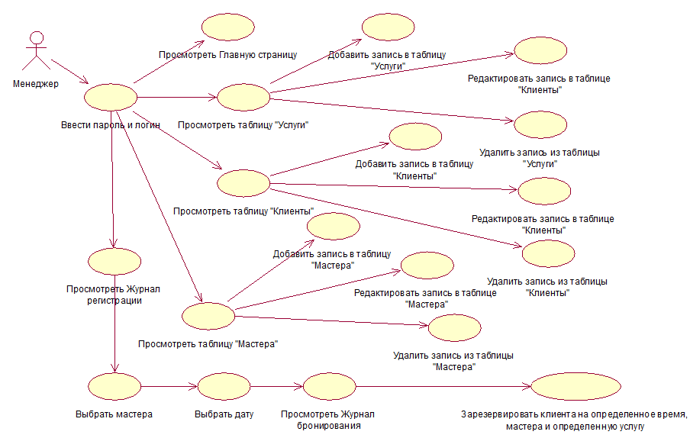

Приложение Б

Диаграмма последовательности

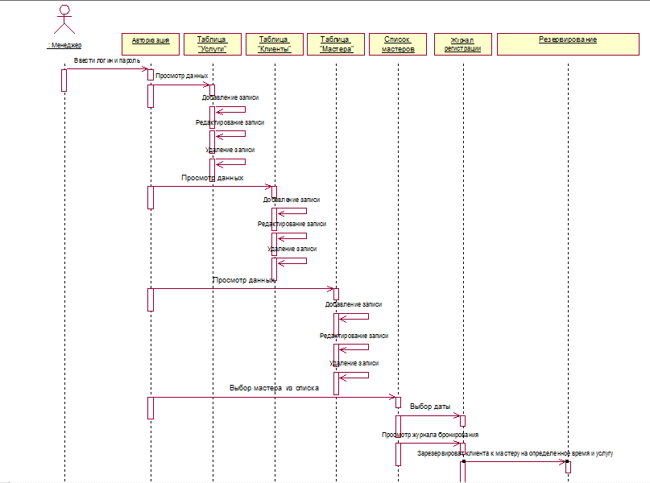

Приложение В

Диаграмма состояния

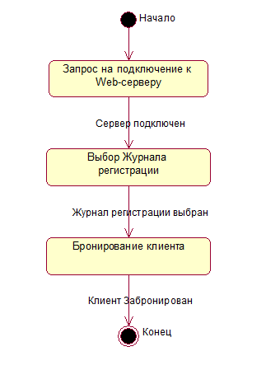

Приложение Г

Диаграмма развертывания
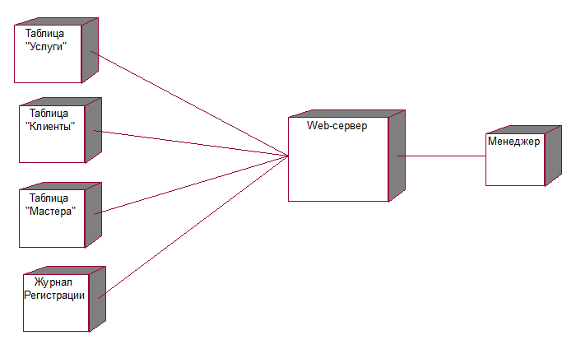

Приложение Д

Диаграмма компонентов
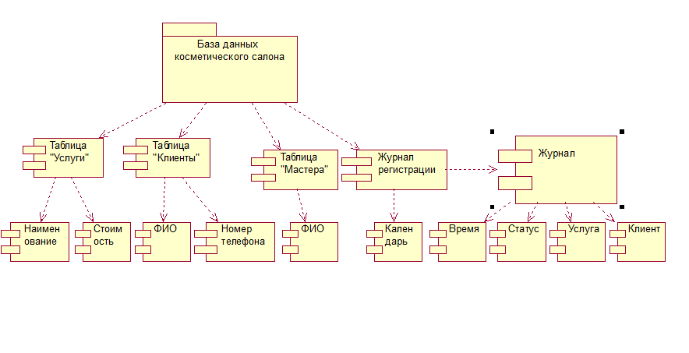

Приложение Е

Диаграмма классов

Приложение Ж

Диаграммы методологии IDEF0

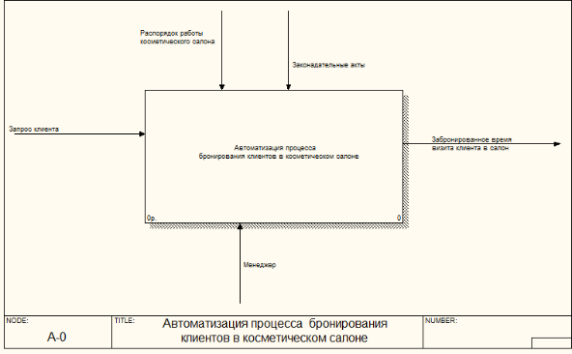

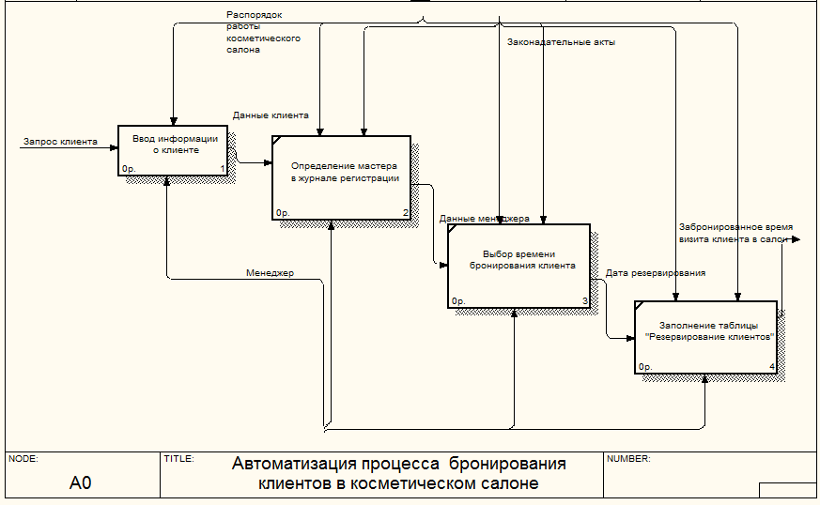

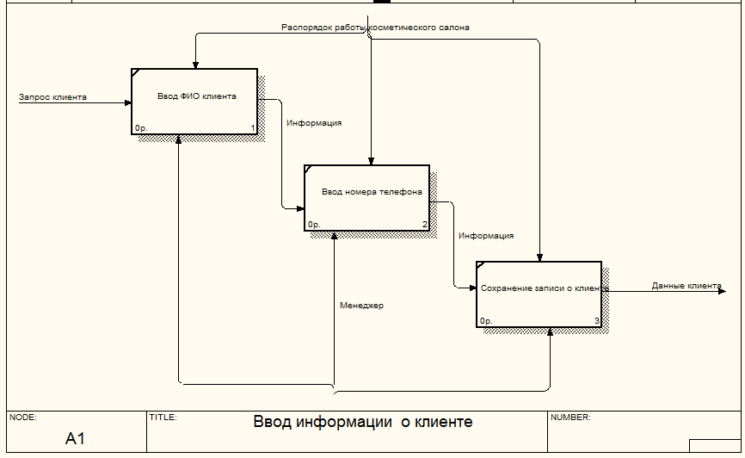

Приложение З

Листинг программы

//RegisterController.java
package ru.data.controller;

import org.springframework.beans.factory.annotation.Autowired;
import org.springframework.stereotype.Controller;
import org.springframework.validation.BindingResult;
import org.springframework.web.bind.annotation.*;
import ru.data.model.bo.*;
import ru.data.servicies.ClientService;
import ru.data.servicies.MasterService;
import ru.data.servicies.PriceService;
import ru.data.servicies.RegisterService;

import java.io.UnsupportedEncodingException;
import java.sql.SQLException;
import java.text.DateFormat;
import java.text.ParseException;
import java.text.SimpleDateFormat;
import java.util.ArrayList;
import java.util.Date;
import java.util.Map;

@Controller
public class RegisterController {

@Autowired
private MasterService masterService;

@Autowired
private RegisterService registerService;

@Autowired
private PriceService priceService;

@Autowired
private ClientService clientService;

@RequestMapping(value = "/register")
public String register(Map<String, Object> map) throws SQLException {
map.put("masterList", masterService.getAllMaster());
return "register";
}

@RequestMapping(value = "/register/{masterId}")
public String registerByMaster(@PathVariable("masterId") Long id, Map<String, Object> map) throws SQLException, ParseException {
map.put("viewsList", getViews(id, null));
map.put("master", masterService.getMasterById(id));
return "register";
}

@RequestMapping(value = "/showreg")
public String registerByMasterView(
@RequestParam(value = "id") Long id,
@RequestParam(value = "date") String date,
Map<String, Object> map) throws SQLException, ParseException {

map.put("viewsList", getViews(id, date));
map.put("master", masterService.getMasterById(id));

return "register";
}

@RequestMapping(value = "/reserve")
public String reserve(
@RequestParam(value = "resId") Long id,
@RequestParam(value = "resDate") String date,
@RequestParam(value = "resHour") Integer hour,
Map<String, Object> map) throws SQLException, ParseException{

Date fullDate = getDate(date, hour);
map.put("fullDate", convertFullDateToStr(fullDate));
map.put("master", masterService.getMasterById(id));
map.put("clientsList", clientService.getAllClients());
map.put("priceList", priceService.getAllPrices());

map.put("register", new RegisterCreation());
return "reserve";
}

@RequestMapping(value = "/saveReg", method = RequestMethod.POST)
public String saveReg(
@ModelAttribute("register") RegisterCreation register,
BindingResult result) throws SQLException, UnsupportedEncodingException, ParseException {
Register reg = new Register();
reg.setMasterId(register.getMasterId());
reg.setClientId(register.getClientId());
reg.setDate(convertFullDateToDate(register.getDate()));
reg.setPriceId(register.getPriceId());
registerService.addRegister(reg);

return "redirect:/cosmSalon/register/"+register.getMasterId().toString();
}

@RequestMapping(value = "/delRegister")
public String deleteClient(
@RequestParam(value = "regId") Long regId) throws SQLException {

Register reg = registerService.getRegisterById(regId);
Long masterId = reg.getMasterId();
registerService.deleteRegister(reg);

return "redirect:/cosmSalon/register/"+masterId;
}

private ArrayList<RegisterView> getViews(Long id, String date) throws SQLException, ParseException{
Date fDate = new Date();
fDate.setHours(0);
fDate.setMinutes(0);
fDate.setSeconds(0);

if(date!=null)
fDate = convertToDate(date);

ArrayList<RegisterView> viewList = new ArrayList<RegisterView>();
ArrayList<Register> list = registerService.getRecordsByMasterId(id);
Date iterDate = fDate;
for(int i = 9; i < 18; i++){
RegisterView view = new RegisterView();
iterDate.setHours(i);
view.setDate(iterDate);
view.setDateStr(convertTimeToStr(iterDate));
view.setHour(i);
boolean setted = false;
for(Register reg: list){
if(convertFullDateToStr(reg.getDate()).equals(convertFullDateToStr(iterDate))){

Clients client = clientService.getClientById(reg.getClientId());
view.setClientName(client.getLastName()+" "+client.getName());
view.setClientId(client.getId());

Price price = priceService.getPriceById(reg.getPriceId());
view.setCost(price.getCost());
view.setPriceName(price.getName());

view.setRegId(reg.getId());
view.setStatus("Забронировано");
setted = true;
break;
}
}
if(!setted)
view.setStatus("Свободно");

viewList.add(view);

}
return viewList;
}

private Date convertToDate(String date) throws ParseException{
DateFormat format = new SimpleDateFormat("dd-MM-yyyy");
return format.parse(date);
}

private String convertFullDateToStr(Date date){
DateFormat format = new SimpleDateFormat("dd-MM-yyyy HH:mm");
return format.format(date);
}

private Date convertFullDateToDate(String date) throws ParseException{
DateFormat format = new SimpleDateFormat("dd-MM-yyyy HH:mm");
return format.parse(date);
}

private String convertToStr(Date date){
DateFormat format = new SimpleDateFormat("dd-MM-yyyy");
return format.format(date);
}

private String convertTimeToStr(Date date){
DateFormat format = new SimpleDateFormat("HH:mm");
return format.format(date);
}

private Date getDate(String date, Integer hour) throws ParseException{
Date res = convertToDate(date);
res.setHours(hour);
return res;
}
}
//Encoder.java
package ru.data.servicies;

import ru.data.model.bo.Clients;

import ru.data.model.bo.Master;
import ru.data.model.bo.Price;

import java.io.UnsupportedEncodingException;

public class Encoder {

public static Clients clientEncoder(Clients client) throws UnsupportedEncodingException {
if(client!=null)
{
client.setPhoneNum(strEncoding(client.getPhoneNum()));
client.setLastName(strEncoding(client.getLastName()));
client.setName(strEncoding(client.getName()));
client.setSurName(strEncoding(client.getSurName()));
}
return client;
}
public static Master masterEncoder(Master master) throws UnsupportedEncodingException {
if(master!=null)
{
master.setLastName(strEncoding(master.getLastName()));
master.setName(strEncoding(master.getName()));
master.setSurName(strEncoding(master.getSurName()));
}
return master;
}

public static String strEncoding(String str) throws UnsupportedEncodingException {
String newStr = null;
if (str != null) {

newStr = new String(str.getBytes("ISO-8859-1"), "UTF-8");
}
return newStr;
}

public static Price priceEncoder(Price price) throws UnsupportedEncodingException {
if(price!=null)
{
price.setName(strEncoding(price.getName()));
}
return price;
}
}
//HelloTag.java
package ru.data.tags;

import ru.data.servicies.Settings;

import javax.servlet.jsp.tagext.*;
import javax.servlet.jsp.*;
import java.io.*;
import java.util.Date;

public class HelloTag extends SimpleTagSupport {

public void doTag() throws JspException, IOException {
JspWriter out = getJspContext().getOut();
out.println("Оператор: "+ Settings.user);
}
}
//MasterDAOImpl.java
package ru.data.DAO;

import org.hibernate.SessionFactory;
import org.springframework.beans.factory.annotation.Autowired;
import org.springframework.stereotype.Repository;
import ru.data.model.bo.Master;

import java.sql.SQLException;
import java.util.ArrayList;

@Repository
public class MasterDAOImpl implements MasterDAO {

@Autowired
private SessionFactory sessionFactory;

@Override
public void addMaster(Master master) throws SQLException {
sessionFactory.getCurrentSession().save(master);
}

@Override
public void updateMaster(Master master) throws SQLException {
if(null!= master)
{
sessionFactory.getCurrentSession().clear();
sessionFactory.getCurrentSession().update(master);
}
}

@Override
public void deleteMaster(Long id) throws SQLException {
Master master = (Master) sessionFactory.getCurrentSession().load(Master.class, id);
if (null != master) {
sessionFactory.getCurrentSession().delete(master);
}
}

@Override
public ArrayList<Master> getAllMaster() throws SQLException {
return (ArrayList<Master>) sessionFactory.getCurrentSession().createQuery("from Master").list();
}

@Override
public Master getMasterById(Long id) throws SQLException {
Master master = new Master();
String query = "from Master where id="+id.toString();
ArrayList<Master> list = (ArrayList<Master>) sessionFactory.getCurrentSession().createQuery(query).list();
try
{
master=list.get(0);
}
catch (IndexOutOfBoundsException e)
{
master = null;
}
return master;
}
}

